Creating Accessible Documents

Microsoft Word, Microsoft Excel, Microsoft PowerPoint, and PDFs

Table of Contents

1. Introduction 6

1.1. Document Purpose 6

2. Built-In Automated Checks 6

2.1. Built-In Accessibility Checkers in Office Apps 6

2.2. Accessibility Checker in Adobe Acrobat 7

3. Accessibility Standards and Practices 9

3.1. Web Content Accessibility Guidelines (WCAG) 9

3.1.1. The POUR Principles 9

3.1.2. Levels of Conformance 10

3.2. Section 508 10

3.3. Accessible Electronic Document Community of Practice (AED CoP) 10

4. Accessibility Concerns Shared by All Doc Types 11

4.1. File Formatting 11

4.1.1. Proper File Type 11

4.1.2. Descriptive File Name 11

4.1.3. Editing Restrictions in Documents 12

4.1.4. Macros 12

4.2. Content Formatting 12

4.2.1. Color Contrast Ratio 12

4.2.2. Color Formatting 13

4.2.3. Avoid Flashing Objects 13

4.2.4. Avoid Using Forms 14

4.2.5. Link Formatting 14

4.2.6. Ensuring Vital Background Information is Accessible 15

4.2.7. Embedded Media Descriptions in Documents 16

4.2.8. Alternative Text (Alt Text) 16

5. Microsoft Word Documents 18

5.1. Disable Restricted Editing in Word 18

5.2. Reveal Formatting Pane 18

5.3. Headings 18

5.3.1. Testing Headings 19

5.3.2. Custom Headings 19

5.4. List Formatting 20

5.4.1. Testing Lists 20

5.4.2. Ordered versus Unordered 21

5.5. Column Formatting 21

5.5.1. Testing Column Formatting 22

5.6. Table Formatting 22

5.6.1. Inserting a Table in Word 22

5.6.2. Text Wrapping and Tables 23

5.6.3. Testing Table Formatting 23

5.6.4. Data Table Formatting 23

5.7. Language Formatting 25

5.7.1. Setting a different language 26

5.7.2. Testing Language Formatting 26

5.8. Image/Object Formatting 27

5.8.1. Inline with Text 27

6. Microsoft Excel Documents 29

6.1. Remove Restricted Editing in Excel 29

6.2. Organize Content and Ensure Logical Reading Order 29

6.3. Data Tables 29

6.3.1. Adding an Accessible Table in Excel 30

6.3.2. Is it a Table or a Picture? 30

6.3.3. Is the Header Row properly recognized? 30

6.3.4. Does the table have a name? 31

6.4. Adding Alt Text to Images and other Objects in Excel 32

7. Microsoft PowerPoint Documents 32

7.1. Remove Restricted Editing in PowerPoint 32

7.2. Clean Presentation Layout and Logical Reading Order 32

7.2.1. Slide Layout 33

7.3. Reading Order 33

7.3.1. Hiding Objects in Selection Pane 34

7.4. Formatting Columns 34

7.5. Formatting Lists 35

7.6. Auto-Creating Data Tables 35

7.6.1. Identify a Header Row 36

7.6.2. Table Color Contrast and Borders 36

7.6.3. No Pictures of Tables 36

7.7. Headers and Footers in PowerPoint 36

7.8. Language Formatting 37

8. PDF Documents 37

8.1. PDF Overview 37

8.2. Tag Types 38

8.2.1. Container Element Tags 38

8.2.2. Heading and Paragraph Element Tags 38

8.2.3. Label and List Element Tags 39

8.2.4. Special Text Element Tags 39

8.2.5. Table Element Tags 39

8.2.6. Inline-level Element Tags 40

8.2.7. Special In-line Element Tags 40

8.3. Accessibility PDF Checklist 40

8.4. Converting a Document into PDF 42

8.4.1. Method A: Converting scanned and non-scanned documents into PDF using Adobe DC 42

8.4.2. Method B: Converting files into PDF within Microsoft Office applications 42

8.5. Testing PDFs for Accessibility 43

8.5.1. Document Properties 43

8.5.2. Document Contents 44

8.5.3. Using Acrobat Accessibility Full Check 48

8.5.4. Adobe's Read Out Loud Text to Speech Tool 48

8.6. Remediating PDF Accessibility 49

8.6.1. Document Properties 49

8.6.2. Document Content – Auto-Tagging a PDF 49

8.6.3. Manually Adjusting PDF Tags 49

8.6.4. Using the New Tag tool 51

8.7. Converting Scanned Documents into Accessible PDFs 55

8.7.1. How to Identify Scanned Pages 55

8.7.2. How to Perform Optical Character Recognition 56

8.7.3. How to Enhance Scanned Pages 56

8.7.4. How to Evaluate the OCR Results 56

8.7.5. How to Edit Textual Content of a PDF 56

8.7.6. How to Make the PDF Fully Accessible 57

8.7.7. How to support signed memorandums as Section 508 conformant PDFs 57

9. Resources 58

9.1. Government Sites and Documents 58

9.2. Microsoft Sites and Documents 58

9.3. W3C Sites and Documents 59

9.4. AED CoP Links 59

9.5. Additional Resources 59

10. Glossary 59

11. References 59

12. Change Log 59

1. Introduction

Creating Accessible documents is incredibly important for the progression of society. An inaccessible document locks people out of information through no fault of their own. This can result in poor communication of information, lack of educational/employment opportunities, alienating individuals, and more. By creating accessible documents, you help avoid these issues and make the world a more inclusive place for all.

* 1. Document Purpose

This document will help guide you through some of the best practices regarding creating Accessible documents and some of the factors that influence what is considered accessible. Additional resources that can help you better understand the content presented here can be found in the **Resources** section later in this document.

This document is not an exhaustive list of methods, regulations, and features that relate to Accessibility by any means. New features are being added and we are finding different methods that work based on Accessibility need every day. Accessibility is ever evolving just like technology and society. This guide is meant to give you a place to start your journey towards helping make the world a bit more Accessible for all.

1. Built-In Automated Checks

Office applications, and many Adobe applications, feature built-in Accessibility Checkers. These will run automated checks on documents to find many common issues that may be present.

However, it is also important to ensure you perform manual checks as well. Some things could be marked as issues when they aren’t, or not marked as issues when they are. Automated checks cannot always account for what kind of data is present in the document, which may impact how it needs to be formatted to be considered accessible.

For instance, a data table is different from a decorative or formatting table. They have different formatting requirements, but an automated check is not going to be able to accurately make the distinction.

* 1. Built-In Accessibility Checkers in Office Apps

Office apps, both desktop and web based, have an Accessibility Checker built in since the 2016/2019 based versions. These are commonly accessed using the **Review** ribbon in the menu bar, or by going to “**File** ribbon > **Info** > **Check for Issues** > **Check Accessibility**.”

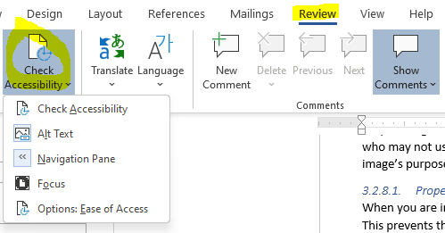

Figure : Check Accessibility under the Review ribbon in Word

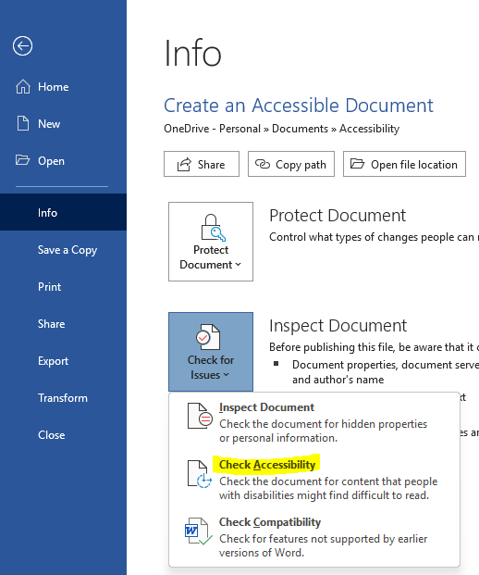

Figure : Info pane under the File ribbon with the Check Accessibility option highlighted

* 1. Accessibility Checker in Adobe Acrobat

Adobe Acrobat contains a built in Accessibility Checker tool that is accessed using the **Accessibility Tools** button.



Figure : Accessibility Tools

Once in the Accessibility Tools options you will be given the option to set “Reading Options” for when you have Adobe Acrobat run its built-in document reader, run a “Full Check”, or render an “Accessibility Report” for the file.

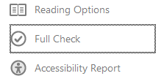

Figure : Accessibility Full Check Command

If you select to do a “Full Check”, you will be presented with a variety of customization options for your scan and then you can click “Start Checking” to begin the scan, or “Cancel” to exit without running a scan of the file.

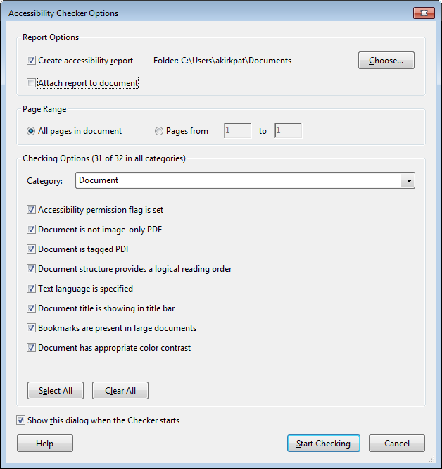

Figure : Accessibility Checker Option Dialogue

If you run a check, you will be presented with a report at the end that describes the results of the check so you can resolve any issues found if needed.

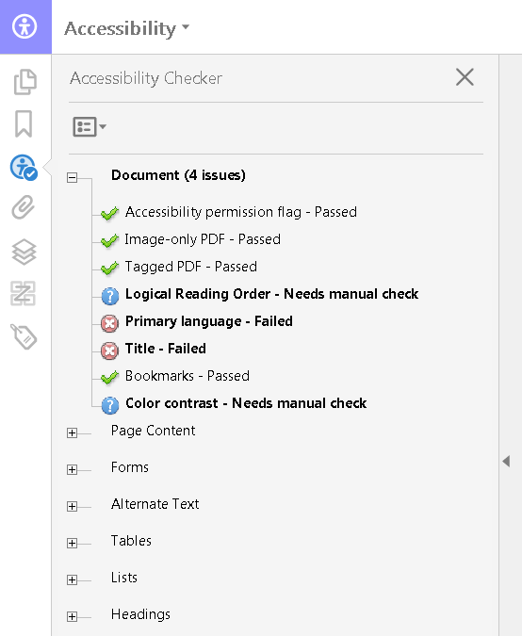

Figure : Accessibility Checker Results Panel

After a check has been run, it can be formatted into a report.

Learn more about the Adobe Acrobat built-in Accessibility checker at the following Adobe article: [Using the Acrobat Pro DC Accessibility Checker](https://www.adobe.com/accessibility/products/acrobat/using-acrobat-pro-accessibility-checker.html)

1. Accessibility Standards and Practices

There are a variety of regulations, standards, and practices revolving around Accessibility. This section will cover some of the most commonly recognized ones relevant to individuals within the United States (US), or working with US companies and/or organizations.

* 1. Web Content Accessibility Guidelines (WCAG)

The **Web Content Accessibility Guidelines** (**WCAG**), were developed by the **Web Accessibility Initiative** (**WAI**) of the **World Wide Web Consortium** (**W3C**) in cooperation with various individuals and organizations worldwide. They were initially published in 1999 and have since undergone multiple revisions. As of July 2021, the current version is 2.1, which was first approved in June 2018. Version 2.2 is scheduled to be finalized by the end of 2021.

The WCAG have become the foundation for most Accessibility regulations, standards, and practices. Section 508, ADA, and more are heavily influenced by the evolution of WCAG. In many cases, meeting the recommended level of conformance with WCAG standards will get you incredibly close to meeting any accessibility regulations you are required to meet for documents, web applications, and software applications.

* + 1. The POUR Principles

As of version 2.1, WCAG focuses on 13 Guidelines divided into 4 primary principles known as the POUR principles, which are **Perceivable**, **Operable**, **Understandable**, and **Robust**. Each of these 4 principles is laid out in the following sub-sections with their applicable guidelines listed. View the [WCAG 2.1 site](https://www.w3.org/TR/WCAG21/) for more information on each principle along with its relevant guidelines and success criterion.

* + - 1. Perceivable

The **Perceivable** principle states that Information and user interface components must be presentable to users in ways they can perceive.

* + - * 1. Relevant Perceivable Guidelines

The main guidelines that apply to the Perceivable principle include:

* **Guideline 1.1:** Text Alternatives: Provide text alternatives for any non-text content so that it can be changed into other forms people need, such as large print, braille, speech, symbols, or simpler language.
* **Guideline 1.2:** Time-based media: Provide alternatives for time-based media.
* **Guideline 1.3:** Adaptable: Create content that can be presented in different ways (for example simpler layout) without losing information or structure.
* **Guideline 1.4:** Distinguishable: Make it easier for users to see and hear content including separating foreground from background.
  + - 1. Operable

The **Operable** principle states that user interface components and navigation must be operable.

* + - * 1. Relevant Operable Guidelines

The main guidelines that apply to the Operable principle include:

* **Guideline 2.1:** Keyboard Accessible: Make all functionality available from a keyboard.
* **Guideline 2.2:** Enough Time: Provide users enough time to read and use content.
* **Guideline 2.3:** Seizure and Physical Reactions: Do not design content in a way that is known to cause seizures.
* **Guideline 2.4:** Navigable: Provide ways to help users navigate, find content, and determine where they are.
* **Guideline 2.5:** Input Modalities: Make it easier for users to operate functionality through various inputs beyond keyboard.
  + - 1. Understandable

The **Understandable** principle states that information and the operation of user interface must be understandable.

* + - * 1. Relevant Understandable Guidelines

The main guidelines that apply to the Understandable principle include:

* **Guideline 3.1:** Readable: Make text content readable and understandable.
* **Guideline 3.2:** Predictable: Make web pages appear and operate in predictable ways.
* **Guideline 3.3:** Input Assistance:Help users avoid and correct mistakes.
  + - 1. Robust

The **Robust** principle states that content must be robust enough that it can be interpreted reliably by a wide variety of user agents, including assistive technologies.

* + - * 1. Relevant Robust Guidelines

The main guidelines that apply to the Robust principle include:

* **Guideline 4.1:** Maximize compatibility with current and future user agents, including assistive technologies.
  + 1. Levels of Conformance

Each guideline is divided up into Success Criteria that better define how to reach one of the 3 levels of conformance to WCAG standards for a particular guideline. These levels are **A**, **AA**, and **AAA**.

Conformance level **A** is considered the lowest level of conformance and level **AAA** is the highest. In general, it is recommended that you aim for at least AA level conformance overall, and AAA where applicable and/or possible.

AAA tends to be more specialized in terms of audience and material presented. It is not possible to meet all success criteria for AAA conformance. You can learn more about WCAG conformance levels by reading the [Conformance](https://www.w3.org/TR/WCAG21/#conformance) section of WCAG 2.1.

* 1. Section 508

In 1986, Section 508 (29 U.S.C. § 794d) was added as an amendment to the Rehabilitation Act of 1973. The amendment was added to help remove barriers to information that can prevent access by individuals with disabilities. It applies to the way in which Federal agencies develop, procure, maintain, and use **Information and Communication technologies** (**ICT**).

Section 508 requires US Federal agencies and federal contractors receiving funds from the US government to make their electronic and information technology accessible to their employees and members of the public with disabilities that is comparable to the access granted to others.

* 1. Accessible Electronic Document Community of Practice (AED CoP)

The **Accessible Electronic Document Community of Practice** (**AED CoP**), which is a part of the Federal CIO Council, was created by a group of Federal Subject Matter Experts (SMEs) with the goals of:

* Improving accessible content posted on Federal agency websites
* Advancing the field of accessibility
* Creating reusable accessibility information and artifacts

They created various guides containing steps that can be used to make an electronic document Section 508 compliant.

1. Accessibility Concerns Shared by All Doc Types

The items in this section are Accessibility concerns regardless of doc type. So they are listed here rather than repeating them in each doc type section.

* 1. File Formatting

Items in this section deal with how you set up the file itself before adding in content.

* + 1. Proper File Type

Make sure to save documents with the newest file extension for the respective app. This helps to ensure better compatibility with newer **Assistive Technology** (**AT**).

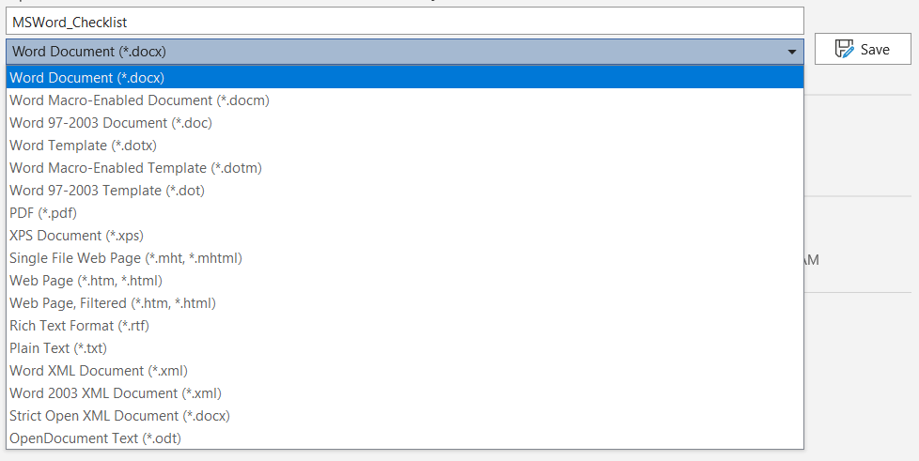

Figure : Microsoft Word file save dialogue.

A list of some of the relevant file extensions can be found below:

* **Microsoft Word:** .docx instead of .doc
* **Microsoft Excel:** .xlsx instead of .xls, .csv, or .xml
* **Microsoft PowerPoint:** .pptx instead of .ppt
  + 1. Descriptive File Name

Ensure the file name helps to differentiate the file from other files and gives the user an idea of what the document contains. Doing so also helps all users more readily identify an individual document amongst a group of documents. When the file names are descriptive, finding a specific file is far quicker even under stressful circumstances.

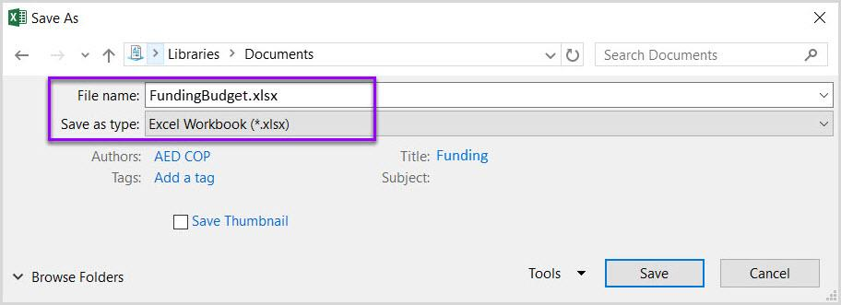

Figure : Excel file with .xlsx file extension and descriptive name

The table below gives examples of file names that are not descriptive, versus ones that are. This also helps to visualize how these documents would look like if they were all grouped together in the same location.

| Non-descript Filename Example | Descriptive Filename Example |
| --- | --- |
| Untitled.docx | MSWord_Checklist.docx |
| Untitled.xlsx | Budget2021.xlsx |

Table : Filename examples

* + 1. Editing Restrictions in Documents

Document restrictions limit or prevent users of AT from reading or editing the document in part because they interfere with how AT interact with the file content. If you must use document restrictions, ensure assistive technology users have access to the password necessary to turn them off. In some cases, AT may make minor alterations to a document to make it accessible to the user, or may need to interact with elements beneath the content to properly hook in and interpret it for the user.

To help you visualize it, think of when you open a Microsoft Office document from online and the Office application won’t let you print it or edit the file until you manually save it to your computer. This is a form of document editing restriction, often caused by the document initially being in a temporary file location or a form of protection that may be turned on to prevent documents from potentially unsafe locations from causing trouble.

**NOTE:** Ways to disable restricted editing in particular documents are listed under their respective sections of this document.

* + 1. Macros

When testing a document containing macros for accessibility, it is important to use a more software baseline method of Accessibility testing. Documents containing macros tend to have a different file extension from those that do not. Some example file extensions are listed below:

* **Microsoft Word: docm** or **dotm**
* **Microsoft Excel: .xltm** or **.xlsm**
* **Microsoft PowerPoint: .pptm** or **.potm**
  1. Content Formatting

The following items are content formatting elements that are shared across doc types, and the methods by which they are applied are similar or intuitive enough to generally not require explanation.

* + 1. Color Contrast Ratio

**Contrast ratio** is the ratio between maximum and minimum brightness. A proper contrast ratio ensures that there is enough difference between 2 colors that they are less likely to blur together as the brightness of a screen is changed and helps make content more distinguishable as the surrounding light increases and decreases. Contrast ratio is impacted by the colors, font size, and font weight.

Improper contrast can make reading content difficult for everyone, particularly those who are colorblind or have low vision. If your content is effectively black on a white background, or close to it, you probably have nothing to worry about. However, it is a good idea to test to be sure. The [Color Contrast Analyzer tool](https://www.tpgi.com/color-contrast-checker/) is great for this, and is the tool recommended by the DHS OAST for their Trusted Testers. It is available for Windows and Mac.

Once you have the tool downloaded and installed, you can launch it. From there you can manually enter color Hexes, select them from a menu, or use the dropper tool to select the section whose color you wish to use in your comparison. From there the tool will tell you if the colors contrast enough to pass AA and/or AAA WCAG compliance.

AA is typically considered the minimum goal to achieve, with AAA being great if you can without impacting your ability to at least meet AA in other areas, or impacting the function of your file, document, and/or application.

Please note that some color combinations may only pass if they are large text, and not if they are standard size text. You can see more details in the table below:

| Type or Size of Text | Contrast Ratio |
| --- | --- |
| Standard Text (12 pt regular) | 4.5:1 |
| Large Test (14 pt bold or 18 pt regular) | 3:1 |

Table : Table detailing font sizes and expected contrast ratios

It is important to note that incidental text, text overlaid on images, and logotypes are excluded from this requirement.

| Good Color Contrast | Insufficient Color Contrast |
| --- | --- |
| White text on black background  Approximate ratio 21:0:1 | Dark gray text on a black background  Approximate ratio 3:1 |
| Dark green text on yellow background  Approximate ratio 7.6:1 | Orange text on a yellow background  Approximate ratio 2.1:1 |
| Light blue text on dark blue background  Approximate ratio 10.5:1 | Red text on a dark blue background  Approximate ratio 1.1:1 |
| White text on a red background  Approximate ratio 6.5:1 | Dark green text on a red background  Approximate ratio 1.3:1 |

Table : Examples of good and insufficient contrast for comparison

* + 1. Color Formatting

Color formatting is important to ensure visual elements are clearly visible and their information is more clearly conveyed. This means making sure that information is not purely conveyed using color or shapes.

If information is only conveyed through shapes or colors, you will not give comparable access to individuals who are blind, colorblind, or have low vision. You risk an inconsistent conveying of information because the colors or shapes could be interpreted differently by different people based on how they are able to view it. As a result, it is important to use additional methods to convey meaning if color or shape would be the sole method otherwise.

Please note that the table below lists the color names under the example labeled “List using only colors” to ensure someone using AT knows what is being shown while still being able to have the effect of no relevant information about the list being conveyed. If you included text describing the color in the field, it could technically count as conveying the needed information, if you described elsewhere what the colors represent in the context.

| Project | Status |
| --- | --- |
| Project A | [Color Green] |
| Project B | [Color Yellow] |
| Project C | [Color Red] |

Table : Project Status table with statuses only conveyed using colors:

| Project | Status |
| --- | --- |
| Project A | On Time |
| Project B | At Risk |
| Project C | Late |

Table : Project Status table with statuses conveyed using text and color.

* + 1. Avoid Flashing Objects

Except for PowerPoint documents, flashing objects are not considered accessible in most doc types since you often cannot properly control how frequently they flash or have controls to stop them from playing located in a quickly accessible location for the user. As a result, they can pose a lot of dangers for individuals with certain seizure conditions.

It is highly recommended to avoid using flashing elements in all documents altogether. If you feel you must include a flashing object, limit the flashes to 3 or less per second, and give the user a way to disable it if at all possible.

* + 1. Avoid Using Forms

You cannot create a Word, Excel, or PowerPoint document with form fields that is considered Section 508 compliant. It is better to create forms in a web/software application or PDF where additional tools are available to properly associate fields and labels, and ensure proper navigation.

* + 1. Link Formatting

Most AT will recognize links as being links if they are interactive links. If they are simply text, then it will read them off as text. However, there are other things you need to be aware of when creating links; if your intent is to make them the best they can be.

* + - 1. Descriptive Link Text

The link text needs to be descriptive of what the link navigates too. Do not simply label them as “Click Here” and often it is good to avoid spelling out the full URL unless the document is to be printed, or the link is relatively short and clear in meaning. The table below shows 3 examples:

| Uniquely Named Link | Link Determinable within context | An unclear link name with no context |
| --- | --- | --- |
| [www.section508.gov](http://www.section508.gov) | [Get My Section 508 Questions Answered](https://section508.gov/content/help-and-faq) | [click here](https://www.opm.gov/) |

Table : Link formatting examples

A lengthy URL may seem to not be problematic, but they can be cumbersome to users regardless of whether they are using AT. This is particularly the case when the links are included in with other text. Below is an example using the URL for a job posting as an example:

| Full URL | Link Formatted with Descriptive Text |
| --- | --- |
| <https://recruiting2.ultipro.com/SOR1001SORE/JobBoard/1fe5e40e-4e0c-4b11-86e3-9a8e1f396263//OpportunityDetail?opportunityId=0102542c-4a92-46ca-b366-cbf35fced749&utm_source=LINKEDIN&utm_medium=referrer> | [Software Test Engineer | Sorenson Communications, LLC Opportunities (ultipro.com)](https://recruiting2.ultipro.com/SOR1001SORE/JobBoard/1fe5e40e-4e0c-4b11-86e3-9a8e1f396263/OpportunityDetail?opportunityId=0102542c-4a92-46ca-b366-cbf35fced749&utm_source=LINKEDIN&utm_medium=referrer) |

Table : Full URL versus Descriptive Link Text

Which of the above examples would be more pleasing to see in a paragraph?

Which link has a meaning that is easier to identify?

Which would you prefer having read off to you? This is particularly important since most AT will state that a link is a link if it is an interactive link. AT will then proceed to read the displayed text for the link. As a result, if you just have the URL written out, the AT user will have to listen to a lengthy URL rambled off to them that may not give them any additional useful information about the link’s purpose.

* + - 1. Microsoft Edge and Links

If you copy a link from Microsoft’s Chromium-based Edge browser into Microsoft Word, you may notice that it will automatically format the link text with the page’s title. This can be helpful for pasting a link into a document with already accessible, descriptive link text. However, you may want to edit it down some depending on how the web page designer formatted their page titles. For example, in the previous job posting example, you may want to edit it down so it reads better in the context of other text as shown below:

| Original Pasted Link Text | Edited Link Text |
| --- | --- |
| [Software Test Engineer | Sorenson Communications, LLC Opportunities (ultipro.com)](https://recruiting2.ultipro.com/SOR1001SORE/JobBoard/1fe5e40e-4e0c-4b11-86e3-9a8e1f396263/OpportunityDetail?opportunityId=0102542c-4a92-46ca-b366-cbf35fced749&utm_source=LINKEDIN&utm_medium=referrer) | [Software Test Engineer job posting with Sorenson Communications](https://recruiting2.ultipro.com/SOR1001SORE/JobBoard/1fe5e40e-4e0c-4b11-86e3-9a8e1f396263/OpportunityDetail?opportunityId=0102542c-4a92-46ca-b366-cbf35fced749&utm_source=LINKEDIN&utm_medium=referrer) |

Table : Descriptive Link Text Examples

* + 1. Ensuring Vital Background Information is Accessible

Information stored in the background, headers, footers, or in watermarks is not accessible to AT. Thus, this content should ideally be duplicated near the beginning of the document, cell A1 if in a spreadsheet, if it is vital to properly understanding and distributing the document’s content.

For example, if you have a watermark stating that the document is confidential or a draft. This is information that can impact the user’s understanding of the content, and how they share the content with others. Thus, it should be duplicated within the body of the document, preferably near the top of it. Some examples are shown below:

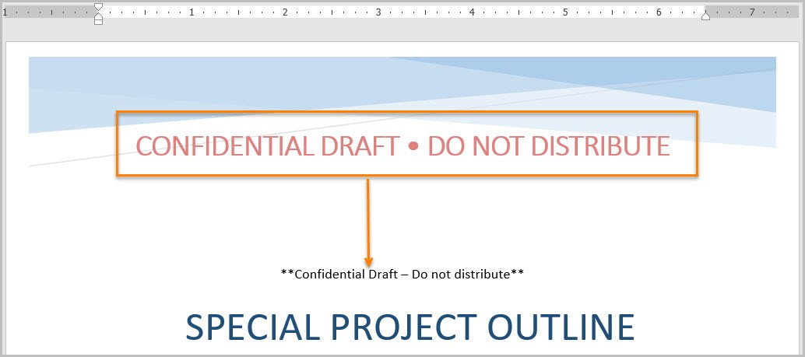

Figure : Example of a watermark displayed in the body of a Word document

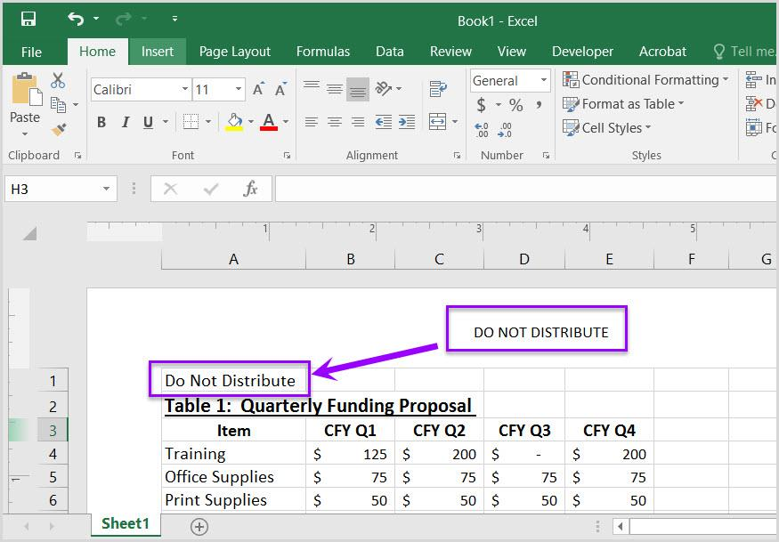

Figure : Example of vital information repeated in cell A1 of the worksheet

**NOTE:** PowerPoints are different in this regard. In PowerPoints it is possible to add the header and/or footer to the reading order. A section titled “Headers and Footers in PowerPoint” has been included under the PowerPoint portion of this document that explains how to do this.

* + 1. Embedded Media Descriptions in Documents

Information in this section applies if you have embedded audio, video, or multimedia files. Ensure there is the following for each of these media types:

* **Audio Only**
  + Accurate and complete transcript
* **Video Only**
  + Accurate and complete text description
* **Synchronized Media (Audio and Video)**
  + Accurate and complete synchronized captions and audio descriptions
    1. Alternative Text (Alt Text)

It is important that all images, and other objects like smart shapes, have clear descriptive text if they convey meaning in the document.

**NOTE:** Technically, you do not need alt text if there is text near the image describing it, though alt text can still help identify the image so the user can associate the image with the surrounding text rather than risk it being identified generically as an image when the user selects it. Alt Text can also help provide additional visual information that is needed and not included in the surrounding text, or caption, but helps the user better understand the context of the image.

In most cases, it is best to limit it to 1-2 sentences unless more detail is needed. The pane will give additional recommendations for things to consider when typing alt text.

When trying to figure out what to write for alternative text, think about the purpose of the image and not what the image looks like. The alternative text should fully convey the meaning of the image and not focus on what the image is. If you replaced the image with just the alternative text, would key information be lost? If the answer is no, you most likely provided properly descriptive Alt Text.

Make sure to include any text present in the object, and include alt text for logos since they are always considered informative. Make sure that the alt text is descriptive and accurately represents what is conveyed by the object.

* + - 1. Adding Alt Text in Office Applications

Adding Alt Text is super easy. Simply right-click an image, or other object, and select the “Edit Alt Text” option from the context menu that displays. An **Alt Text** pane will display where you can type in a brief description of the image.

Additional information on adding Alt Text in Office applications can be found in the following Microsoft Support video/article: [Improve accessibility with alt text](https://support.microsoft.com/en-us/office/video-improve-accessibility-with-alt-text-9c57ee44-bb48-40e3-aad4-7647fc1dba51).

**NOTE:** There are additional considerations that need to be made for alt text in Excel documents. Please view the alt text section of the Excel portion of this document for details.

* + - 1. Adding Alt Text in Adobe Acrobat

To add Alt Text to an image, or other object, in an Adobe Acrobat PDF, you can use the **Accessibility Tools** or the **Tags** panel. Additional information on adding Alt Text to PDFs can be found in the following Adobe article: [PDF Accessibility Repair: Examine the Document](https://www.adobe.com/accessibility/products/acrobat/pdf-repair-add-alternative-text.html).

* + - 1. Decorative Images/Objects

If an image is decorative, for example a background image, stylized borders, or one that just adds color to the document. These are things that do not convey any information to the reader. Open the **Alt Text** pane as described in the previous section, but make sure to check the box labeled “Mark as decorative.”

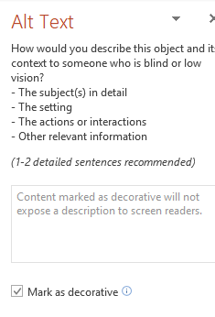

Figure : Alt Text options in PowerPoint

If the “Mark as Decorative” option is not available, you can indicate that an image is decorative by placing 2 quotes with a single space between them (“ ”) in the “Description” field provided under the Alt Text options.

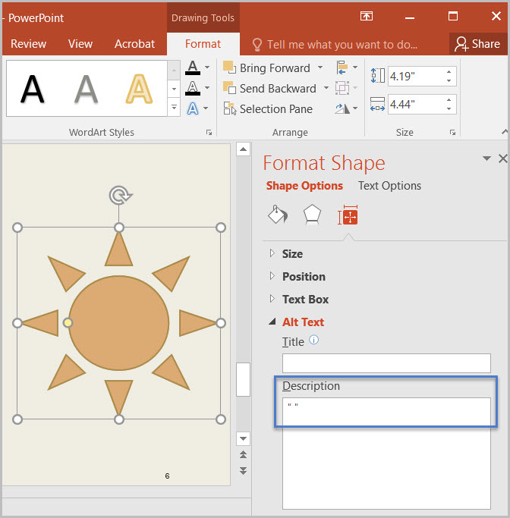

Figure : Alternative Alt Text options in PowerPoint with the quotes to indicate the image is decorative used.

1. Microsoft Word Documents

This section will detail ways to ensure your Microsoft Word documents are Accessible. Some of these are probably things you are doing already, but others may be things you never would have considered as needed to make the document accessible. Some things are required before you ever start adding content to the file.

* 1. Disable Restricted Editing in Word

As mentioned previously, editing restrictions in documents can make all, or part, of a document inaccessible. To turn off editing restrictions in Word documents:

1. Select the “Review tab>Restrict Editing”
2. Look to see if the “Stop Protection” button appears at the bottom of the “Restrict Editing” pane.
   1. If the “Restrict Editing” pane shows options 1, 2, and 3, then restricted editing is turned off.
3. Click “Stop Protection.”

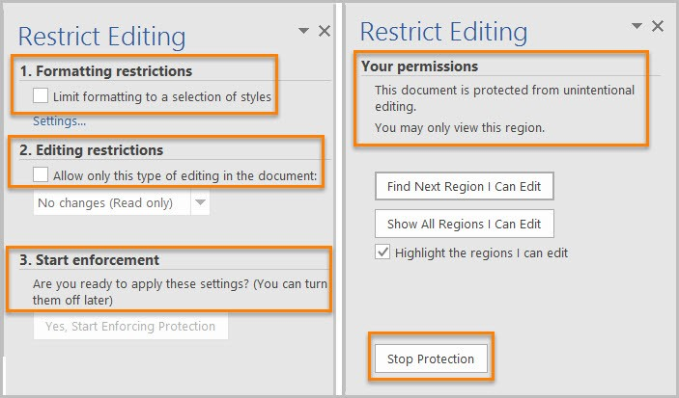

Figure : Restrict Editing pane options

* 1. Reveal Formatting Pane

Often you will see the **Reveal Formatting** pane listed as the method for testing whether something is formatted properly. Anytime you need to open this pane, simply:

1. Select the text you wish to inspect the formatting of or place your cursor within it.
2. Press the **Shift** key and the **F1** key together on your keyboard.

Doing so will open the **Reveal Formatting** pane.

* 1. Headings

If a text item is meant to be a heading, it is not enough for it to visually look like a heading. It needs to use a proper heading style in Word.

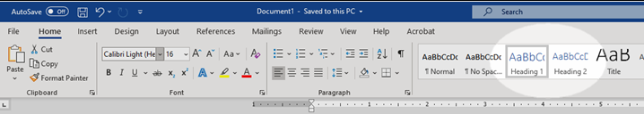

Figure : Heading Styles in Microsoft Word

* + 1. Testing Headings

To pass this, all headings must show up appropriately in the **Navigation pane** of Word. This is particularly important since Assistive technology can not infer meaning purely based on how you chose to manually format the text.

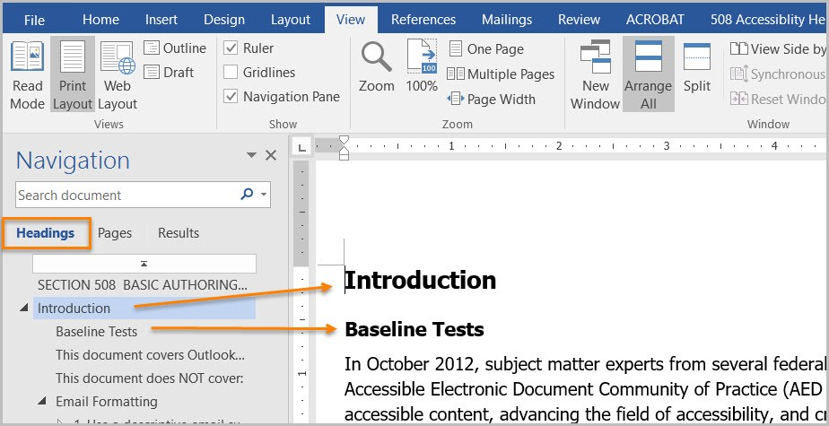

Figure : Microsoft Word Navigation Pane.

Properly formatted headings that show up properly in the Navigation pane also serve to make the content more easily navigated in general regardless of whether AT is being used.

* + 1. Custom Headings

If you need a custom heading look that is not offered by Microsoft Word, you can create a custom one. However, make sure to set the settings correctly so that the heading is recognized as the proper heading level by Word.

To do so, make sure to set the “**Style based on**” option to the appropriate heading level when you are modifying your new heading style. Also make sure to select “**Linked (paragraph and character)**” from the “**Style type**” drop-down if it is not already selected. Finally, set the “**Style for following paragraph**” to “**Normal**” to ensure that it automatically switches to the normal paragraph font when you go down the next line after a header.

It is also important that a custom heading have a descriptive name that helps identify what its purpose is. This will help anyone else using your custom heading later and will help you if you need to go back and use it in the future.

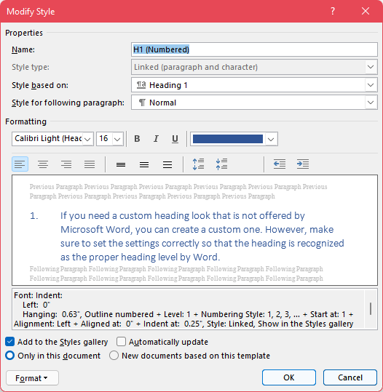

Figure : Modify style dialogue window

* 1. List Formatting

Lists being properly formatted in a document ensures that AT can properly infer order and meaning. This means making sure to use list styles built into Microsoft Word. Word does give you the option to make custom list styles, similar to how you can make custom heading styles.

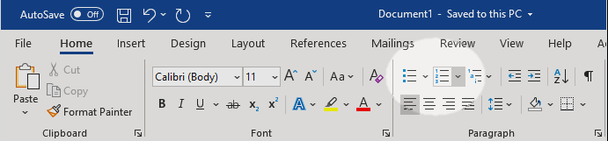

Figure : List style buttons in Microsoft Word

* + 1. Testing Lists

You can check if a list is properly counted as a list using the **Reveal Formatting pane**. If it is properly formatted, you will see the list information displayed in the pane.

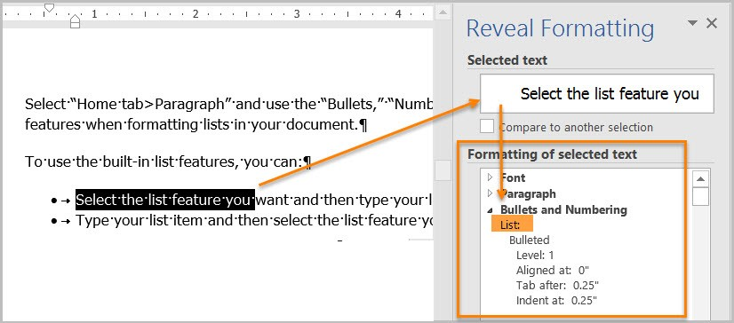

Figure : Microsoft Word Reveal Formatting pane

* + 1. Ordered versus Unordered

**Ordered lists** are used to indicate that the order of the items in the list is significant. They are typically used for lists of steps that need to be completed in a particular order. These lists are typically formatted with list markers like Roman numerals, Arabic numerals, or other alphanumeric characters where order has meaning.

Ordered list formatting should not be used for **Unordered lists**. Items in unordered lists don’t necessarily need to be listed in a particular order, though you may still choose to list them in some form of logical order (**e.g.** listing ingredients based on what part of the dish they are used in and the order in which those parts are made in the instructions). Unordered lists could include lists of ingredients in a recipe, hardware in a box, etc.

* 1. Column Formatting

When you wish to organize content in a Word document into columns, it is important to use the built in **Column** options to do so. Attempting to give content the look of being in columns using tables, tabbing, or spaces will cause AT to not read the content correctly.

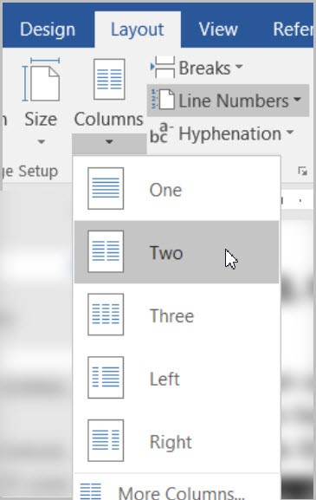

Figure : Column options in Word under Layout Tab

* + 1. Testing Column Formatting

You can use the **Reveal Formatting** pane to test whether columns are properly formatted and recognized by Word as columns. Your content fails if you place your cursor within content that visually appears to be in a column format, but the Reveal Formatting pane does not list them as being in columns.

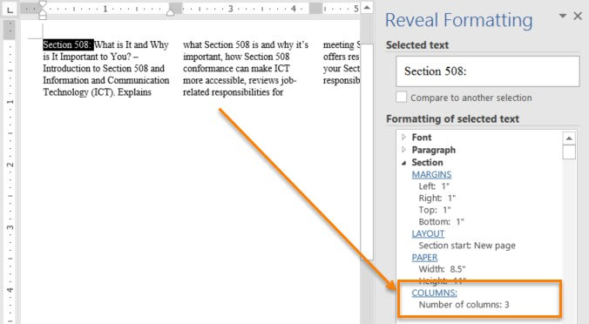

Figure : Reveal Formatting pane recognizing columns

* 1. Table Formatting

Properly formatting tables in Microsoft Word ensures that information will be properly recognized by AT. You should make sure to use the built-in table inserting option, and not just visually create a table using spacing, tabs, or indentions. If content is merely formatted to visually look like a table without being inside a table, AT will not be able to properly infer that it is a table.

Do not use pictures of tables or tables with merged or split cells. These are not accessible because the table information is often not able to be properly conveyed by AT, or AT is unable to read the information in a meaningful way. Also do not nest one data table inside of another table.

* + 1. Inserting a Table in Word

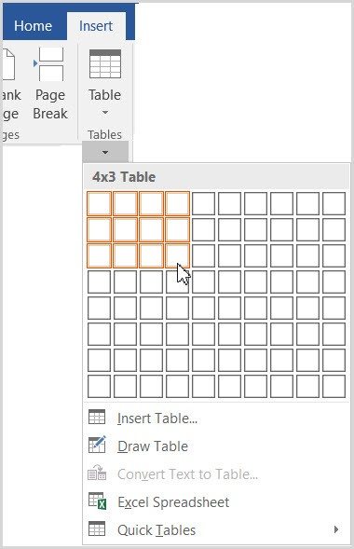

Figure : Table option found under the Insert ribbon in Word

After selecting the **Table** option under the **Insert** ribbon in Word, you can either manually select the number of columns and rows using the boxes displayed or select the **Insert Table** option to be taken to a dialogue box where you can type in the number of rows and columns you wish your table to have.

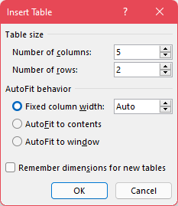

Figure : Insert Table window

* + 1. Text Wrapping and Tables

You should turn off Text Wrapping around tables in Microsoft Word. Allowing text to wrap around a table can cause AT to not properly read the table and the surrounding content.

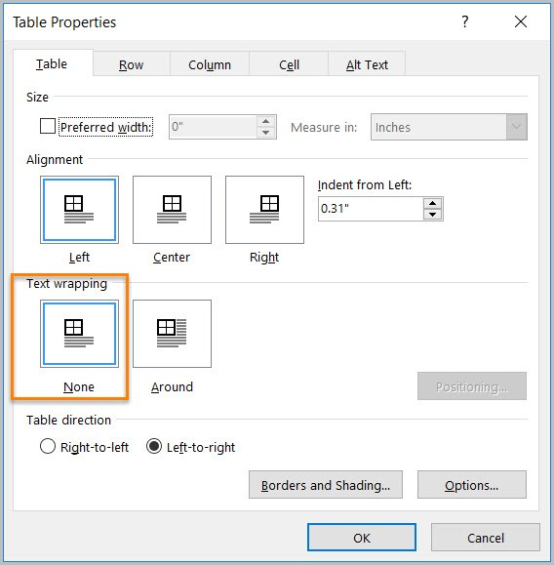

Figure : Table Properties window with text wrapping set to None

* + 1. Testing Table Formatting

The easiest way to test your table is whether you used the built-in table tool in Word to create it. If so, then you are okay. Your table fails if you instead used tabs, spacing, and indentions to create the visual look of a table.

Can you tab through your table? Does it tab through in a way that matches the visual layout of the content? Many AT users will use a keyboard to navigate content. Therefore, it is important to properly format a table in Word so that it can be properly tabbed through. If your table can be tabbed through, and the tab order matches the visual appearance of the table, your content passes.

* + 1. Data Table Formatting

**Data Tables** are tables where there is a specific relationship between cells. For instance, a header row that describes what information is stored in the cells below it.

Data tables can be problematic for AT if not properly formatting. The relationship between the individual data items can be lost. Generally, data tables are best saved for web applications where WAI-ARIA can be used to better define the relationship between different cells. They also work out better in Excel spreadsheets.

* + - 1. Avoid Split or Merged Cells

AT cannot properly identify the relationship between data in split and merged cells. As a result, it is best to avoid them at all costs in Word documents. This is a just because you can do it doesn’t mean you should circumstance.

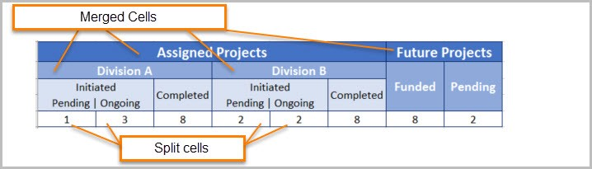

Figure : Complex table with merged and split cells

* + - 1. Don’t use pictures of tables

If you select a table and the “Picture Tools”, or “Picture Format”, ribbon shows up, your table fails because it is an image and not a table. AT will not be able to read the text in the picture, or at least will not be able to read it well enough to identify it as a table and convey the relationship between the various cells of the table.

* + - 1. Ensure the Header Row Repeats

Have you ever seen a table that went across multiple pages, but you had to keep scrolling up to the first page the table was on because the headers were only on that first page? Word has an option to repeat a header row across the top of each page the table is on so the user can easily see the column headers to remember what each is for.

**DO NOT** simply manually recreate the header row on each page. This can lead to confusion because the AT will not recognize the manually created header row as such unless the table on the next page is an entirely separate table from the portion of the table on the previous page.

You can check if a row is properly recognized as a header row and set to repeat by placing your cursor in a cell of the header row, opening the Reveal Formatting pane, and seeing it shows the row set to “Repeat as header row”.

To set this:

1. Place your cursor in one of the cells of the header row and right-click.
2. Select **Table Properties** from the context menu that displays.
3. Under the **Row** table in the **Table Properties**, you will see a check box labeled “Repeat as header row at the top of each page.”

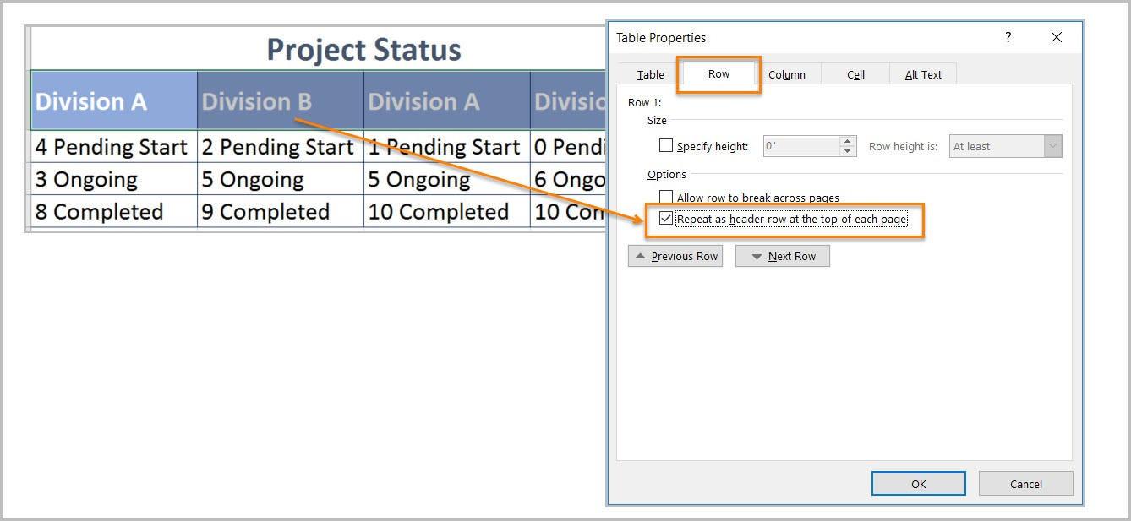

Figure : Table Properties with "Repeat as header row at the top of each page" checked.

It is advised to just turn this on for every table. That way you are covered if it does end up going across multiple pages.

* 1. Language Formatting

If your document is all in one language, then you don’t necessarily need worry about this. However, you can ensure Word recognizes the document as being in all one language by:

1. Highlighting all content in the document.
2. Navigate to the **Review** tab.
3. Click the **Language** button under the **Language** section.
4. Select the **Set proofing language** option.

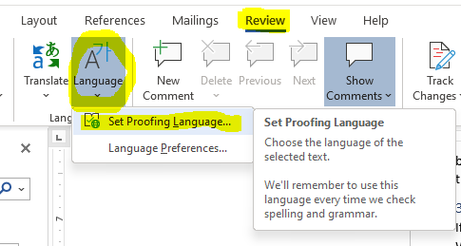

Figure : Language options in Word with Set Proofing Language selected.

1. Select the document’s primary language from the list, and click **OK**.

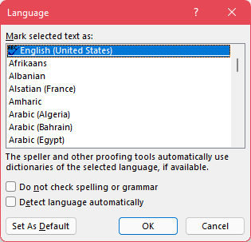

Figure : Proofing language selection menu.

This will ensure that Word recognizes the selected content as the correct language. This is important since it can impact how a screen reader, or other AT, pronounce a particular word when they read it off. Not properly setting the language for a section of text could cause it to be mispronounced, which can alter the meaning of some words.

* + 1. Setting a different language

If you have an individual word or block of text that is in a language other than the predominant one for the document, you can use the same methods shown about to set the language for just that section of text.

Simply highlight the section of text that is in a different language, and then navigate to the **Set Proofing Language** option, but select the language of that section instead of the predominant one for the document.

* + 1. Testing Language Formatting

To test language formatting, refer to the **Reveal Formatting pane** used in previous sections. This time, make sure to place your cursor within the section of text that you know if a language other than the predominant one for the document. The Reveal Formatting pane will display what language it has interpreted the text as being. If a language other than the one of the text is displayed, then you need to highlight the text and change its proofing language.

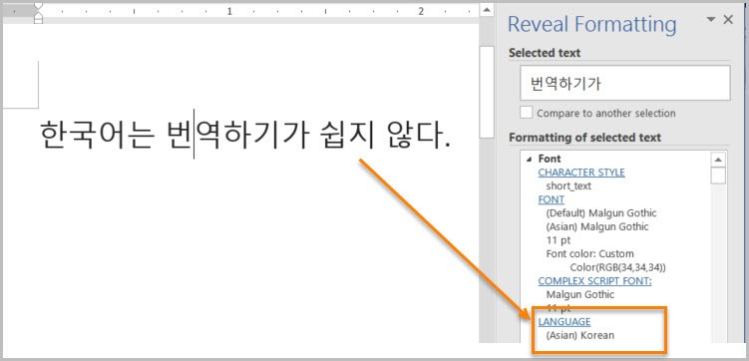

Figure : Reveal Formatting pane identifying language of text

* 1. Image/Object Formatting

This section will cover how we need to format things like images and smart shapes in a document.

* + 1. Inline with Text

It is important that tables, images, and other objects be inline with text and not have text wrapped around them. Text wrapping around objects can cause AT to not properly read the content, or to read it in an unintended order that leads to confusion.

You can use the **Accessibility Checker** to identify objects that are not inline with text.

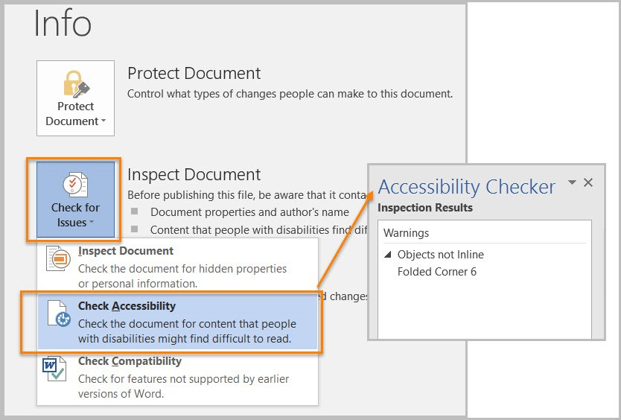

Figure : Accessibility Checker report displaying items not properly inline with text.

To fix items not inline with text, you can:

1. Right-click the object.
2. Select the **Size and Position** option from the context menu.

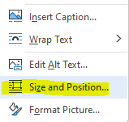

Figure : Object right-click menu with "Size and Position" option

1. Navigate to the **Text Wrapping** tab of the resultant **Layout** window that displays.

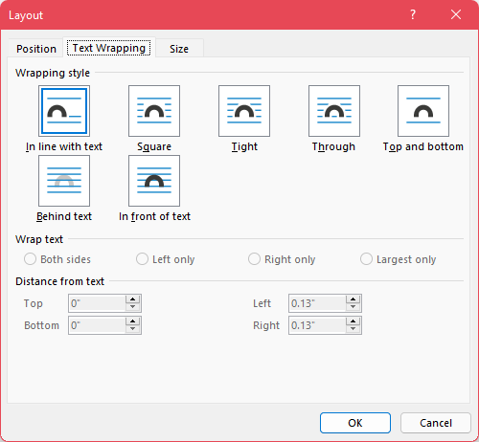

Figure : The "Text Wrapping" tab of the "Layout" window.

1. Select the “In line with text” option and click **OK**.
   * + 1. Properly Inserting Images

When you are inserting a picture file, using the **Insert** ribbon in Word will allow you to properly insert them inline with text. This prevents the image from floating about and being in some way wrapped by the text that can interfere with AT reading the content in the proper order.

When pasting an image into a Word document, one thing that can help make sure the image gets properly recognized as an image and is formatted in a way that makes it more accessible, do not simply use ctrl+V to paste the image in. Instead, use the right-click context menu to paste the image in so you can select the “Picture” icon under the “Paste Options.”

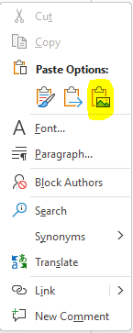

Figure : Right-click Context Menu in Word with Picture paste option highlighted.

1. Microsoft Excel Documents

This section will contain information on what you can do to make your spreadsheets made in Microsoft Excel more accessible to anyone who may need to view them.

* 1. Remove Restricted Editing in Excel

As explained in prior sections, documents that have had restrictions turned on cannot be properly tested for Accessibility because those restrictions can interfere with AT reading the document.

In Excel, to remove restrictions, go to “File” tab, “Info”, then “Protect Worksheet.” Select “Restricted Permission by People” and check “Unrestricted Access.” Ensure that end users using AT have access to any passwords necessary to turn off these restrictions.

* 1. Organize Content and Ensure Logical Reading Order

Logical reading order in an Excel spreadsheet is considered left to right and top to bottom with the starting point being cell A1.

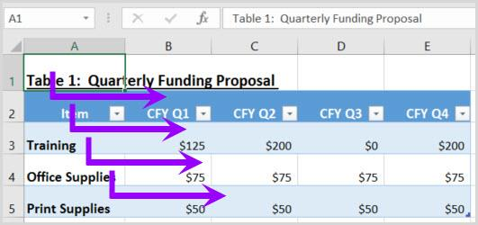

Figure : Spreadsheet with content that follows the logical/visual reading order.

To ensure users can follow the flow of information in your spreadsheet, consider the following:

* **If the spreadsheet is part of a workbook,** make sure each spreadsheet tab has a descriptive and unique name. The name of the tab should provide a clue to what information is being covered in the spreadsheet.
* **Use the Cell Style tool to apply Heading levels,** otherwise known as section levels, such as Title and Heading Level 1 through Heading Level 9. To modify the appearance of the Heading Level, right mouse click on the Heading Level and select Modify.
* **If the content in the spreadsheet needs to be in a data table format,** use the Format as Table tool. Identify a table template that best meets your needs and then modify the template by right mouse clicking on the template and select Modify.
* **Lastly, if data cells require special formatting**, use the Format tool to format the cell.
  + Check out the AED CoP testing guides and checklists listed in the **Resources** section of this document.

Additionally, you want to make sure that content doesn’t span over multiple rows or columns, start content in cell A1 every time, and that it can be navigated using the up, down, left, and right arrow keys in a way that matches the visual/logical reading order.

* 1. Data Tables

**Data Tables** are when there is a particular relationship between data in various cells. For instance, when you have a header row that describes the data in the cells beneath it. Data tables are a useful way to organize and present data to users.

Tables must be created using built-in Table features so that assistive technology can properly read a table’s information and infer the relationship between cells.

Do not use pictures of tables or tables with merged or split cells. These are not accessible because the relationship between cells is often not able to be properly conveyed by AT, or AT is unable to read the information at all. Also do not nest one data table inside of another table.

* + 1. Adding an Accessible Table in Excel

Assistive technology users need to be able to identify column headers in data tables to understand the association between table cells and their respective headers.

To create an accessible data table, select “Insert>Table.” In the create table pane, choose the range of cells for your data table. Check the “My table has headers” checkbox in the create table pane. Choose any cell and name your table “Table Tools>Design>Table Name”. Choose the first cell in the header column and/or row and update the column and /or row headings with descriptive names. You can also apply a table name by right mouse clicking on a data cell and select Define Name.

* + 1. Is it a Table or a Picture?

You can test if a table is recognized as a table, by clicking in it. If the **Picture Tools** ribbon appears, the table is an image and is not accessible. If you click it, and the **Table Tools** ribbon appears, then it is properly recognized as a table.

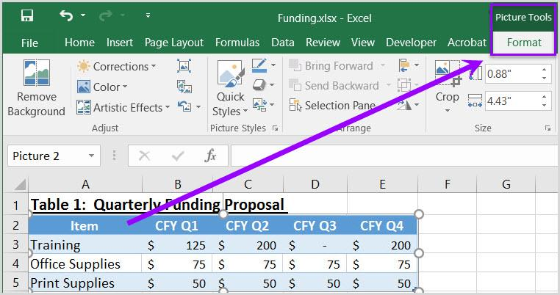

Figure : Example Picture of a Table in Excel

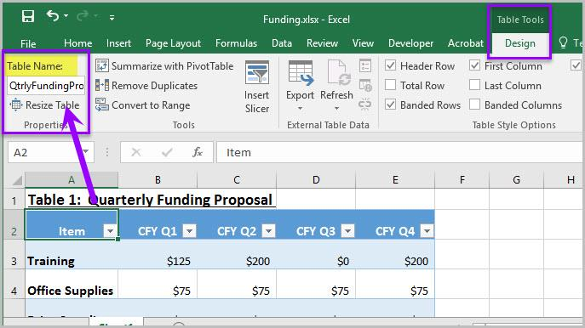

Figure : Properly created table in Excel

* + 1. Is the Header Row properly recognized?

Make sure that when you click on the cells in your header row/column are properly recognized. Place your cursor on the first row and/or column of a table cell and see if the worksheet has identified the header row and/or column.

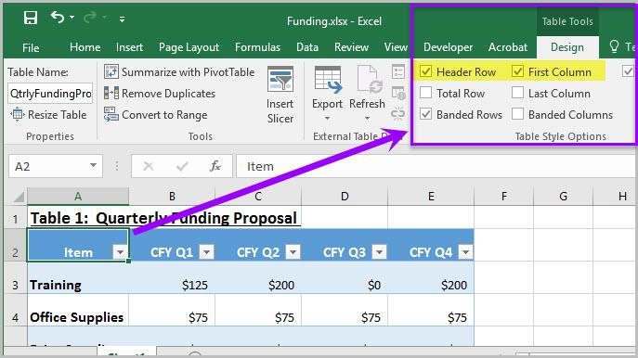

Figure : Header Row options in Design Ribbon

* + 1. Does the table have a name?

You can give tables in Excel a name. This is usually done when you initially create the table with the built-in tools. You can confirm if the table has a name by:

1. Placing your cursor in a table, or otherwise selecting it.
   1. Another method to select tables, if they are properly recognized as a table, is with the “Go To” menu.
   2. The “Go To” menu is accessed by selecting “Home>Editing>Find & Select>Go To” and then selecting any table listed in the options window.
   3. Images of tables will never be listed in the “Go To” options.
2. Once a table is selected, go to the Table Tools ribbon and look under the “Properties” section of the ribbon for the “Table Name” field.



Figure : Table Name in Table Properties

* 1. Adding Alt Text to Images and other Objects in Excel

Just like with other documents, Alt Text is important for images and other objects in Excel. However, there are other things you need to consider when adding images and other objects to an Excel file.

In Excel images, objects, shapes, charts, and other non-text elements cannot be anchored/embedded in a cell. Screen reader users cannot access the alt-text of floating elements. Therefore, you must add descriptive text to images and other objects by adding information in a cell near the object, or list the non-text elements and their descriptions in a separate appendix.

1. Microsoft PowerPoint Documents

[Placeholder Text]

* 1. Remove Restricted Editing in PowerPoint

As mentioned in previous sections, having restricted editing turned on can result in a document being inaccessible to AT. It also interferes with proper Accessibility testing of the document. To test, you will need to turn off restricted editing, and provide user’s with the ability to turn it off as well.

To remove restrictions, go to “File” tab, “Info”, then “Protect Presentation.” Select “Restricted Permission by People” and check “Unrestricted Access.”

* 1. Clean Presentation Layout and Logical Reading Order

Keeping your slide layout simple and clean will help make it easier to establish and maintain a logical reading order that AT can follow and makes sense to users. A complex layout can result in users being unable to easily determine the relationship between information and objects on a slide.

Try using the built-in themes available in PowerPoint to get started. These can be accessed when you initially go to create a PowerPoint from the **New** menu, or at any time from the **Themes** section of the **Design** ribbon in PowerPoint. If you select a theme from the **Design** ribbon, you can also view variants of an applied theme, if available, in the **Variants** section.

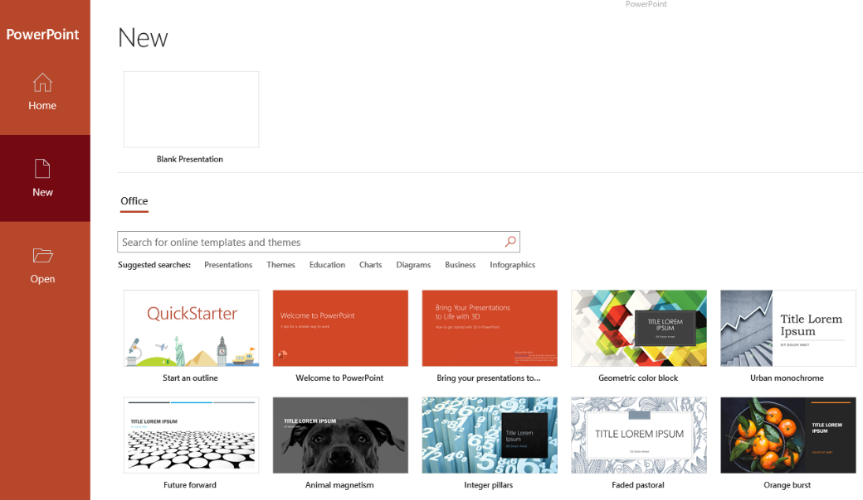

Figure :PowerPoint theme options in the New menu

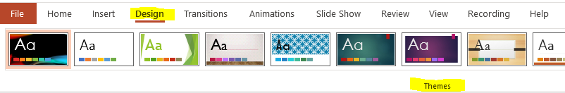

Figure : Built-In PowerPoint Themes on the Design tab

A selected theme can be customized to better fit your needs by selecting the **Format Background** option from the **Design** ribbon.

If none of the themes meet your needs, select “View>Slide Master” from the PowerPoint to customize individual slide backgrounds and layouts.

1. **Avoid using colored or patterned backgrounds that make it difficult to read content on the slide.** When using background colors that are similar to the foreground, content might blend into the background.
   1. Similarly, patterned backgrounds might obscure foreground content.
   2. Ensure proper contrast between text and foreground elements.
2. **Use a font that is easy to read.** When possible, avoid using script style fonts such as (**i.e.** Blackadder Italic, Brauhaus 93, and Brush Script MT) Script style fonts can cause eye fatigue.
   1. Additionally, script style fonts are challenging for some individuals with cognitive disabilities or visual impairments to read.
3. While creating an accessible PowerPoint the conditions found in the [AED CoP PowerPoint Testing Checklist](https://www.section508.gov/create/presentations) must be considered.
   1. The answers to all the conditions should be Yes or NA (not applicable).
   2. If a No response is selected, the issue must be resolved before the document can be considered accessible.
   3. Each of these conditions can be tested by visually examining the documents Layout Design and Logical Reading Order.
      1. Slide Layout

The layout of elements on a slide is important to ensure the information is clearly conveyed, and helps to maintain the logical reading order.

Many slides include a slide title, usually near the top of the slide along with a variety of placeholders for other content you may want to add. A descriptive title can help prepare users for what information will be presented on a slide, and thus make navigation easier. Make sure to delete unused placeholders so they aren’t inadvertently picked up by AT.

You can edit a slide’s layout at anytime, though the best ways are when you initially create a new slide, and with the **Slide Master**. Changes made using the Slide Master can be used to alter the **Master Layout**, which will then cause those changes to be applied to any other slide in the presentation that uses that layout.

You can also simply create a wholly new slide layout. If you do, make sure to give your new layout a descriptive name.

* 1. Reading Order

You can customize the tab, or reading, order of elements on a slide to better ensure they are read in a logical order by a AT. Reading order should make sense with the visual layout of the slide. To edit the reading order:

1. Navigate to the **Home** ribbon.
2. Locate the **Editing** section of the ribbon.
3. Click the **Select** drop-down menu, and select the **Selection Pane** option.

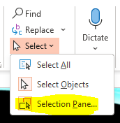

Figure : Selection Pane option in PowerPoint.

1. All objects on the slide will be listed in the pane. Reading order starts from the bottom of the list and moves upward. Move objects by clicking their names and using the up/down arrow buttons on the pane, or click and drag items, to move them up and down in the list.

You can also access the Selection Pane by going to the **Drawing** section of the **Home** ribbon, selecting the **Arrange** drop-down menu, and then selecting the **Selection Pane** option from there.

The reading order of items tends to be based on when they were added to the slide. So if you add new items to the slide after editing the reading order, they will be placed at the end of the reading order.

* + 1. Hiding Objects in Selection Pane

To the right of each item in the Selection Pane list is an eye icon. Toggling it can cause items to be hidden visually, but they will still be read by a screen reader.

* 1. Formatting Columns

Formatting columns is important in a PowerPoint for the same reasons that it is important in Word. If you just make items visually appear to be columns on a slide, they may not be interpreted properly. They could be read in the wrong order, or lines could be read together that don’t go together.

Formatting the text into columns using the **Column** options found in the **Paragraph** section of the **Home** ribbon, will best ensure Accessibility with AT. You can also use this menu option to verify if text was properly formatted into columns. Simply place your cursor in the text that appears to be in columns and open the menu. If you see an option highlighted that matches the number of columns on the screen, the text was properly formatted with the built-in column tool.

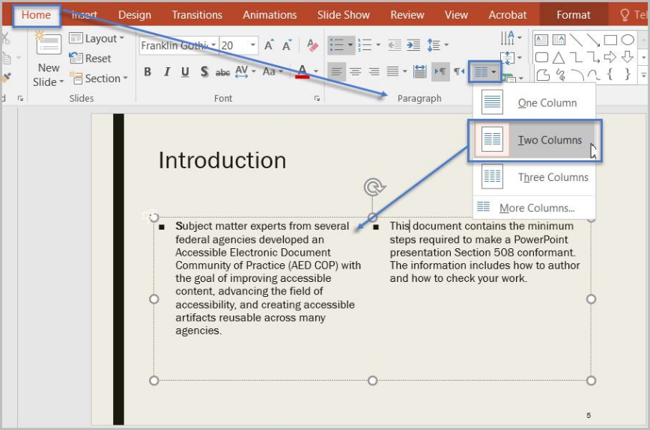

Figure : Text formatted into 2 columns with the Column options in PowerPoint.

* 1. Formatting Lists

Lists should be properly formatted using the built-in list tools in PowerPoint found in the **Paragraph** section of the **Home** ribbon. If you place your cursor in text that appears to be in a list, and one of the list types (**i.e.** bullet lists or numbered lists) does not highlight, the list was not properly formatted.

AT cannot infer that list items are in a list just because they were visually formatted to look like a list. They must be made into a list using the built-in list tools to be properly recognized as such. You can make custom list styles in the list options if you so choose, and this is fine. Custom lists styles made using the built-in list options will be recognized as lists.

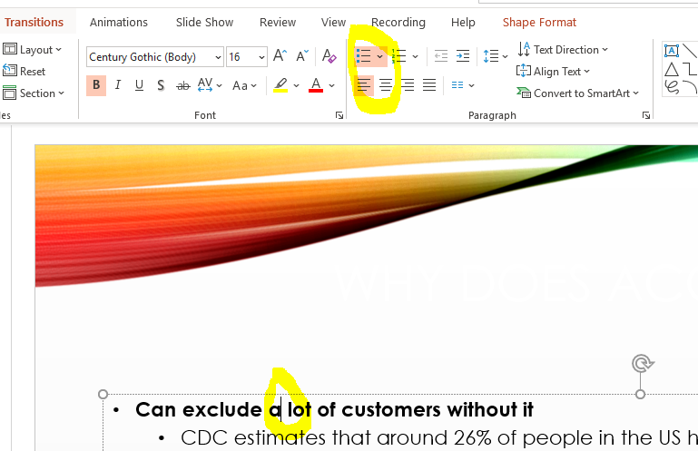

Figure : Bulleted style list built using built-in styles

* 1. Auto-Creating Data Tables

To get your table off on the right foot towards being accessible, it is important to use the built-in table creation tools in PowerPoint. The most common ways to do this are by going to the **Insert** ribbon and selecting the **Table** from the **Tables** section of the ribbon to open the available table insert options.

From there you can either:

* Hover your mouse over the boxes shown to select the size for your table, clicking once you have the number of rows and columns you want highlighted, or
* You can select the **Insert Table** option from the menu and manually type in how many columns and rows you want your table to be.

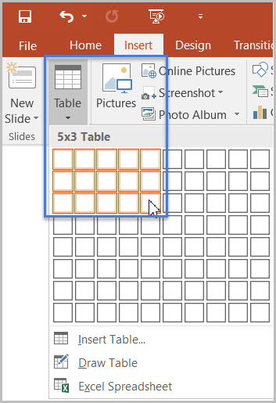

Figure : Table insert options

If you need a more complex data table that has multiple header rows, 1 or more header columns, and/or merged or split cells, then you must convert the presentation to an accessible format such as a PDF document remediated for accessibility. Complex data tables cannot be created and made accessible in Microsoft PowerPoint.

* + 1. Identify a Header Row

To identify the headers in a table:

1. Click inside the table. The **Table Tools** options should become visible, and the **Design** ribbon should be open.
2. If the top row of the table contains headers for each column (most tables do), make sure the **Header Row** checkbox is checked.
3. If the first column of the table contains headers for each row, make sure the **First Column** checkbox is checked.

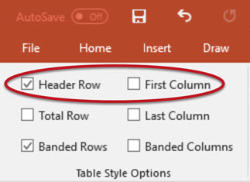

Figure : Table Style Options in PowerPoint

* + 1. Table Color Contrast and Borders

It is also important to ensure that you select a table style that gives enough contrast to the header row to make it more visually identifiable.

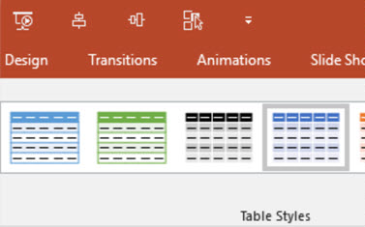

Figure : Table styles displaying some of the color and row style options available.

* + 1. No Pictures of Tables

As with other document formats, you do not want to include pictures of tables. You want to instead recreate the table using the built-in table creation tools in PowerPoint. Pictures of tables cannot be interpreted by AT for users in a meaningful way. You can tell if a table is an image or a properly created table by selecting the table and seeing what set of tools shows up in the menu ribbon. If **Picture Tools** shows up instead of **Table Tools**, your table fails because it is a picture instead of a properly created table.

* 1. Headers and Footers in PowerPoint

In PowerPoint files, it is possible to add the Header and/or Footer to the reading order. To accomplish this, we must enable Headers and Footers and ensure they display in the Selection Pane.

To enable Headers and Footers in your presentation:

1. Select the “Insert” ribbon.
2. In the “Text” group, select “Header & Footer.”
3. Check the “Footer” option.
4. Type in vital information, and select “Apply.”

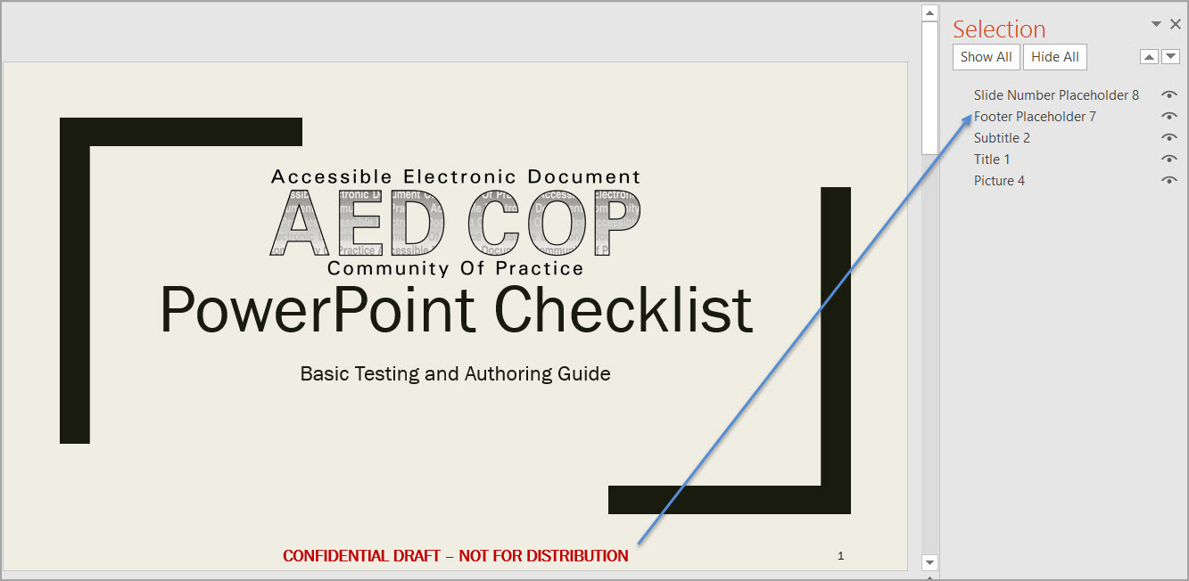

Table : Selection Pane in PowerPoint displaying Footer item in the reading order.

* 1. Language Formatting

Ensuring elements of the document that are in a language other than the predominant one must be marked as such. This ensures AT properly recognizes and pronounces them to avoid miscommunication.

If the presentation contains words or phrases in a language other than the predominant language:

1. Highlight the relevant text.
2. Go to the “Review” tab.
3. In the “Language” group select the “Language” Button.
4. The choose “Set Proofing Language.”
5. Select the relevant language the selected portion is in.
6. Click **OK**.
7. PDF Documents
   1. PDF Overview

**PDF** stands for Portable Document Format. PDFs provide a way to provide a more consistent visual appearance for a document regardless of who views it. PDFs can also contain accessible forms that can be view, printed, and submitted. PDF files are compromised of 3 components: physical view, content view, and tag structure.

* Physical view - which is the physical representation of text and graphics
* Content view - which is the layer of the PDF where the actual document content resides
* Tags Structure Tree - which establishes the PDF content structure and logical reading order

The **Physical view** is a visual representation of the text and graphics. You can also think of this as the Print view, or what the document would look like when printed.

The **Content view** displays the actual textural and graphical information that is displayed on the page. To access the content view of the document, access the Content Pane by going to the View menu item and selecting **Show/Hide** > **Navigational Panes** > **Content**. Expand the document name to view pages and objects.

**NOTE:** For the purposes of this document, whenever we discuss how to navigate a program to perform actions on a PDF, we are discussing the use of Adobe Acrobat.

Lastly, the Tags layer displays the **Tags Structure** Tree which establishes the logical structure of the document, as well as the logical reading order for assistive technology. This will display tags used such as Headers, Paragraphs, Lists, and tables.

To view the Tags Structure Tree, access the Tags Pane by selecting the View menu and then selecting **Show/Hide** > **Navigational Panes** > **Tags**. Selecting the arrow symbol to the left of the tag, will expand the tag and its child element, which is the content on the page that the tag is associated with.

* 1. Tag Types

PDF tags act like HTML tags. They allow you to identify what component an object or section of text is within the document is (i.e. heading, paragraph, label, etc.). There are 37 tag types that authors may use to help define the formatting and structure of a PDF document.

Depending on the source file used to create the PDF, the tags that appear in the PDF's Tags Structure Tree may not display the same name of a tag created by tools within Acrobat. If the tags map to standard Acrobat tags, the tags are considered valid. To verify that custom tags generated from products such as HTML, XML and Microsoft Office correctly map to standard Acrobat PDF tags, you must view the Role-Map of the tag by first selecting the custom tag from the Tags Pane and then select **Options > Edit Role Map** in the Tags Pane. To gain access to the Tags Structure Tree, select the Tags Pane icon to open the Tags Pane

Once the Tags Structure Tree is displayed, press **Shift 8** (*) to expand all tags. To display the tags map or full name of a tag, right click on a tag and select **Properties**. The full name of the tag will appear in the **Tags Type** field. To view a full list of PDF tags, from the Tags Pane, select **Options>New Tags**.

* + 1. Container Element Tags

Container elements are the highest level of element and provide hierarchical grouping for other block-level elements.

| Tag | Description |
| --- | --- |
| <Part> | Part element is a large division of a document; it can be used to group smaller units of content together, such as division elements, article elements, or section elements. |
| <Div> | Division element is a generic block-level element or group of block-level elements. |
| <Art> | Article element is a self-contained body of text considered to be a single narrative. |
| <Sect> | Section element is a general container element type, comparable to Division (DIV Class=“Sect”) in HTML, which is usually a component of a part element or an article element. |

Table : Content Element Tags

* + 1. Heading and Paragraph Element Tags

Heading and paragraph elements are paragraph-like, block-level elements that include specific level heading and generic paragraph tags. A heading (H) element should appear as the first child of any higher-level division. Six levels of headings (H1 to H6) are available for applications that don't hierarchically nest sections.

| Tag | Description |
| --- | --- |
| <H> | Header |
| <H1> | Heading level 1 |
| <H2> | Heading level 2 |
| <H3> | Heading level 3 |
| <H4> | Heading level 4 |
| <H5> | Heading level 5 |
| <H6> | Heading level 6 |
| <P> | Paragraph |

Table : Table Element Tags

* + 1. Label and List Element Tags

[Placeholder Text]

| Tag | Description |
| --- | --- |
| <L> | List element is any sequence of items of similar meaning or other relevance; immediate child elements should be list item elements. |
| <LI> | List item element is any one member of a list; may have a label element (optional) and a list body element as a child. |
| <LB> | Label element is a bullet, name, or number that identifies and distinguishes an element from others in the same list. |
| <LBody> | List item body element is the descriptive content of a list item. |

Table : Label and List Element Tags

* + 1. Special Text Element Tags

Special text elements identify text that isn't used as a generic paragraph.

| Tag | Description |
| --- | --- |
| <BlockQuote> | Block quote element is one or more paragraphs of text attributed to someone other than the author of the immediate surrounding text. |
| <Caption> | Caption element is a brief portion of text that describes a table or a figure. |
| <Index> | Index element is a sequence of entries that contain identifying text and reference elements that point out the occurrence of the text in the main body of the document. |
| <TOC> | Table of contents element is an element that contains a structured list of items and labels identifying those items; has its own discrete hierarchy. |
| <TOCI> | Table of contents item element is an item contained in a list associated with a table of contents element. |

Table : Special Text Element Tags

* + 1. Table Element Tags

Table elements are special elements for structuring tables.

| Tag | Description |
| --- | --- |
| <Table> | Table element is a two-dimensional arrangement of data or text cells that contains table row elements as child elements and may have a caption element as its first or last child element. |
| <TR> | Table row element is one row of headings or data in a table; may contain table header cell elements and table data cell elements. |
| <TH> | Table header cell element: is a table cell that contains header text or data describing one or more rows or columns of a table. |
| <TD> | Table data cell element is a table cell that contains non-header data. |

Table : Table Element Tags

* + 1. Inline-level Element Tags

Inline-level elements identify a span of text that has specific formatting or behavior. They are differentiated from block-level elements. Inline-level elements may be contained in or contain block-level elements.

| Tag | Description |
| --- | --- |
| <BibEntry> | Bibliography entry element is a description of where some cited information may be found. |
| <Quote> | Quote entry element is an inline portion of text that is attributed to someone other than the author of the text surrounding it; different from a block quote, which is a whole paragraph or multiple paragraphs, as opposed to inline text. |
| <Span> | Span entry element is any inline segment of text; commonly used to delimit text that is associated with a set of styling properties. |

Table : Inline-level Element Tags

* + 1. Special In-line Element Tags

Similar to inline-level elements, special inline-level elements describe an inline portion of text that has special formatting or behavior.

| Tag | Description |
| --- | --- |
| <Code> | Code entry element is computer program text embedded within a document. |
| <Figure> | Figure entry element is a graphic or graphic representation associated with text. |
| <Form> | Form entry element is a PDF form annotation that can be or has been filled out. |
| <Formula> | Formula entry element is a mathematical formula. |
| < Link> | Link entry element is a hyperlink that is embedded within a document. The target can be in the same document, in another PDF document, or on a website. |
| <Note> | Note entry element is explanatory text or documentation, such as a footnote or endnote, that is referred to in the main body of text |
| <Reference> | Reference entry element is a citation to text or data that is found elsewhere in the document. |

Table : Special In-Line Element Tags

* 1. Accessibility PDF Checklist

When creating an accessible PDF, or when reviewing a PDF for Section 508 conformance, the following conditions must be considered. The answers to all of the conditions should be **Yes** or **Not Applicable**. If a **No** response is selected, the issue must be resolved before the document can be considered accessible. Each of these conditions can be tested by visually examining the document's Physical View, Content layer, and Tags layers. An additional resource is Adobe's Accessibility Full Check tool located on Acrobat's main menu under **Advanced > Accessibility**> **Full Check**.

| Element to Check | Yes/No/NA |
| --- | --- |
| Document Properties  The PDF has a descriptive file name which identifies the document, or its purpose and the Initial View is set to show Document Title.  Security settings is set to Allowed for Content Copying for Accessibility.  Under the Advanced>Reading Options, the primary language is set correctly in the Language field. |  |
| The document contains renderable content.  The document's content appears in the Content Panel.  Optical Corrector Recognition (OCR) was performed on all scanned pages. |  |
| The PDF is Tagged.  When viewing the Tags Panel, tags are visible. |  |
| The tags follow the visual/logical reading order of the document.  All meaningful content is associated with the correct tag.  All tags follow the visual/logical reading order of the page. |  |
| The document has decorative content.  All decorative content (text and objects) are tagged as <Artifact>.  Repeated content such as repeated headers and footers are tagged as <Artifact>. |  |
| Vital information in headers, footers, and watermarks is duplicated in the document's text at least once.  Vital information is duplicated as tagged content. |  |
| Headings are tagged with a <H>-<H6> Heading tag.  Heading tags match document headings and follow the visual outline.  All non-standard heading tags map to standard heading tags. |  |
| Lists are tagged correctly.  Lists have a parent tag and have one or more nested list item tags. Example <L> and <LI>. |  |
| Sections in different languages have a corresponding language attribute.  The tag's property associated with the language change shows the selection's language or corresponding two-letter code. |  |
| Images and other objects have alternative text.  All “Figures” have alternative text that describes its purpose/function.  All captions describe the purpose/function of associated images/objects.  Descriptive text conveys the purpose and/or function of the image/object. |  |
| The document contains data tables.  Tables are identified with a <Table> tag.  Table header cells have a <TH> tag and data cells have a <TD> tag.  Row/column span match the layout, and cells have scope and unique IDs.  Data cells are associated with corresponding header cells. |  |
| The document contains links and/or controls.  Link names describe destination/purpose or describe context.  Links have unique names.  Tab order matches the visual/logical order of interactive elements. |  |
| The document contains fillable form elements.  Each form field has a tooltip that matches the label or instruction.  Tab order matches the visual/logical order of form fields. |  |
| The document contains color and/or Sensory characteristics.  Meaning of color or other sensory characteristics is duplicated in text. |  |
| Color contrast  Text and Large Text (including images of text) pass with the Color Contrast Analyzer. |  |
| The PDF contains meaningful audio-only, video-only, or Synchronized media objects.  Audio-only objects have a transcript that is accurate and complete.  Video-only objects have text description that is accurate and complete.  Synchronized media (audio and video) have synchronized captions and audio description that are accurate and complete |  |
| The document has no flashing objects.  Flashing objects are excluded from the document. |  |
| An alternative accessible version is provided if the PDF cannot be made fully Section 508 conformant.  Alternate versions are equivalent and up to date. |  |

Table : Accessibility PDF Checklist

* 1. Converting a Document into PDF

There are two methods for converting a source document into a PDF. Method A allows you to convert a document using Adobe Acrobat DC tools. Method B is recommended for converting Microsoft Office files into a PDFs by using the Adobe PDF plug-in located on the Office main menu bar.

* + 1. Method A: Converting scanned and non-scanned documents into PDF using Adobe DC

To convert a non-Microsoft Office document into a PDF, first open Acrobat and from the **File** menu select **Create PDF**. Next select **File** > **Open** and your selected file will automatically convert into a PDF. This method may generate either a tagged or an untagged PDF. Untagged or poorly tagged PDFs are not accessible. To verify that the PDF is accessible, use Adobe's **Content Pane**, **Tags Pane**, **Order Pane** and **Accessibility Full Checker** tool to test the PDF. Instructions on how to use these tools are located in **Section 8.5: Testing PDFs for Accessibility**.

If the document you are converting has been scanned, you must first perform Optical Character Recognition, or OCR, on the document before it can be made accessible. If you are unable to highlight or select text in a document, or if the text is blurry or hand-written, it is likely a scanned document. OCR will translate words from the scan into text that can be read by a screen reader and other assistive technologies. Go to **Section 8.7: Converting Scanned Documents into Section 508 Conformant PDFs** for more information on making scanned documents Section 508 conformant.

* + 1. Method B: Converting files into PDF within Microsoft Office applications

Before converting a Microsoft Office document into a PDF, it is important to first verify the document is as accessible as possible. By doing so, the generated PDF will have fewer accessibility issues that will need to be remediated. For guidance on creating and testing Microsoft Office documents for Section 508 conformance, visit the [Test for Accessibility](https://www.section508.gov/test) page on the Section 508 page.

To begin converting an Office document into PDF, first open the desired Office file.

Next, from the Office applications menu bar, select **Adobe PDF** > **Preferences** and from the Preferences properties box, set the desired conversion settings**.**

**Note:** If the Adobe PDF menu item does not appear on the applications bar as shown below, the Adobe PDF plug-in has not been installed. If this is the case, convert the Office file using the instructions in method A.

1. From the **Settings** tab, under **Applications Settings**check the following checkboxes.
   1. View Adobe PDF Results
   2. Prompt for Adobe PDF File Name
   3. Convert Document information
   4. PDF/A Compliance set it to **None**
   5. Create Bookmarks
   6. Add links, and
   7. Enable Accessibility and Reflow with tagged Adobe PDF
2. Next select the **Advanced Settings** button. Once the new window opens, change the **Compatibility** combo box selection to **Acrobat 8.0-1.7**. This setting will ensure that the latest accessibility features are applied to the newly created PDF.
3. Now select **OK** to save conversion settings. Once the settings have been saved, they will remain set unless changed by the user.
4. Lastly, select **Adobe PDF**> **Convert to PDF** from the Office applications menu to create a tagged PDF. When prompted, name the file and save it. Once the conversion process is completed, Adobe DC will launch and display the newly created PDF file.

If the Office document was created using **Formatting and Style** elements, located on the Office toolbar, a well-tagged document will be generated. In most cases, PDF files created using this method are 90% accessible. To verify that the PDF is accessible, use Adobe's Content Pane, Tags Pane, Order Pane and **Accessibility Full Checker** tools to test the PDF. The **Testing PDFs for Accessibility** section of the document will explain how to use the tools described in this section.

* 1. Testing PDFs for Accessibility

Before a PDF can be considered accessible, many factors must be considered. It must contain actual content, be properly tagged, have a logical reading and tab order, and alternative text must be added to all images and objects. Additionally, the Properties of the document must contain a descriptive file name, a specified language and Content Copying for Accessibility should be set to Allowed.

* + 1. Document Properties

The PDF's document properties should contain a few key pieces of information such as a descriptive title, tags, allow copying content for accessibility, and have a specified language.

To view the document properties:

1. First open the PDF and select **File** > **Properties** > **Description**.  
   In the **Title** field, verify that a descriptive title appears. Next navigate to the **Initial View** tab and from the **Show** dropdown box verify that **Document Title is selected.**If the Title field is missing a descriptive title and Document Title is not selected, the PDF is considered not accessible. A descriptive title will need to be added and the Show field will need to be set to Document Title before the PDF can be considered accessible.
2. While on the **Descriptive** tab, verify that the Tagged PDF option is set to “**Yes**”. If the Tagged PDF option is set to “**No**”, the document may not be tagged and therefore it is not accessible. The document will need to be tagged before it can be made accessible.
3. From the **Properties** window select the **Security** tab and verify **Content Copying for Accessibility** is set to **Allowed**. If the option is set to **Not Allowed**, Assistive Technology will not be able to access the PDF's content rendering the PDF not accessible. Change the Security settings to allow content copying for accessibility. Do this by selecting a different security option from the **Security Method** dropdown box or by selecting **Change Settings** and then set the security settings as needed. If the Security Method has been set to **No Security**, then no restrictions for content copying have been applied.
4. Lastly, ensure a primary language is assigned. From the **Properties** window select **Advanced** > **Language** and verify that the proper primary language is assigned to the document. If the language is not set correctly, screen readers will be unable to reliably read the PDF, rendering the PDF not accessible. The correct language will need to be assigned before the document can be considered accessible. If the document contains multiple languages, the language will need to be set as a property of the tag associated with the content that contains a language change before the document can be considered fully accessible.
   * 1. Document Contents

The ***Physical View*** of the document may contain specially formatted text that may represent Heading levels, list, tables, figures and form field elements. Having a clear understanding of the elements that were used to create the document will help you identify what document elements need to be tested for Section 508 conformance.

If content within the PDF appears blurry or contains hand-written information, the document was most likely scanned. Scanned documents may or may not contain actual content. Without actual content, assistive technology will be unable to read or interact with the PDF. To verify that the PDF contains actual content:

1. First Go to Acrobat's **View** menu and select **Show/Hide** > **Navigation Panes** > **Content**
2. Next, expand the Content tree by pressing **CRTL** + **Shift** + **8**
3. Use the Up and Down arrow keys to navigate the **Content Pane**

As you navigate the**Content Pane**, the content of the physical view of the PDF should highlight. If pages in the PDF do not contain renderable content, the document is not accessible and Optical Character Recognition, or OCR, will need to be performed. For more guidance, go to **Section 8.7: Converting Scanned Documents into Section 508 Conformant PDFs**.

After verifying that the PDF contains renderable content, The Tags Structure Tree will need to be examined to ensure all document elements such as **Headers**, **Paragraphs**, **List**, **Data Tables**, **Figures**, and **Form Field** elements are associated with the correct tag. Note: All elements in a PDF must be tagged. If the element is not tagged, it will not be accessible by assistive technology such as screen readers. Elements that are tagged as <Artifacts>, otherwise known as decorative images or repetitive content, will not show up in the Tags Structure Tree; however, the tag will be visible in the Content Pane.

1. Go to Acrobat's View menu and select **Show/Hide** > **Navigation Panes** > **Tags**
2. Next expand the Tags tree by pressing **CRTL** + **Shift** + **8**
3. Use the Up and Down arrow keys to navigate the Tags tree.

As you navigate the Tags tree, the content on the physical view of the PDF will highlight. If the Tag does not properly represent the element on the physical view, the document is considered not accessible, and the tags will need to be modified. If you are uncertain of what type of tag is being used, right click on the tag and select **Properties**. The **Type** field will display the Tag's name. To modify the tag, simply select the correct tag type from the list of tags.

* + - 1. Logical Reading Order

Next use the Tags Structure Tree to verify the documents Logical Reading Order.  Tags must follow the visible logical layout of the page.  Without a proper Logical Reading Order, assistive technology users will find it difficult or impossible to follow the natural flow of the document's content.

1. First open the Tags Pane and expand the Tags Structure Tree
2. Use the Up and Down arrow keys to navigate the Tags Structure Tree

As you navigate the Tags tree, the content on the physical view of the document will highlight.  If the Tags are arranged in such a way that they follow the visible logical layout of the page, the document has a **Logical Reading Order**.  If the tags appear out or order, the **Tags Structure Tree** will need to be rearranged before the PDF can be considered accessible.

* + - 1. Logical Tab Order

Now let's evaluate the **Logical Tab Order**. If the PDF contains links or form field elements such as test boxes or button controls, The PDF must be evaluated for a **Logical Tab Order**.  The **Tab Order** must follow the visible logical layout of the page.

To evaluate the **Tab Order**,

1. First press the **Tab Key** to navigate the document
2. Then verify that the keyboard focus follows the visible logical layout of the page.

When pressing the **Tab** key, if the keyboard focus does not follow the visible logical layout of the page then the document is not accessible, and the Tab Order will need to be adjusted.

* + - 1. Figure Elements

If the PDF includes figure elements that are not decorative, the figures must contain alternative text.  Alternative text is descriptive text that describes the purpose of the image.  Without alternative text, users that are unable see the images in the document will not be able to access all the information provided in the document.

To verify that useful alternative text was used for images:

1. View Figures by navigating to **Tools** > **Accessibility** > **Touchup** **Reading Order**. Then check “**Show tables and figures**.”
2. Next look for text descriptions placed on meaningful images and objects.
3. For images marked by “**Figure**”, right click and select “**Edit Alternate Text**.”
4. Examine all captions associated with images for a text description, and
5. Examine the surrounding content for text that describes the image and other objects.
6. Next check that the descriptive text conveys the purpose and/or function of the image or object.
7. For images of text, check that the descriptive text matches the text contained in the image verbatim.

If the alternative text descriptions are not correct, the document is not accessible, and the alternative text will need to be corrected.

* + - 1. Data Tables

If the PDF contains **Data Tables**, the data table must be tagged using the <**Table**> tag. Additionally, all Column and Row header cells must be tagged with the **Table Header**, or <**TH>** tag. Complex tables containing more than one set of Column headers or that have data cells which span across multiple columns or rows must contain proper **Scope**. **Scope** denotes which data cells are **Row Headers** or **Column Headers**, and **Span** identifies the number of columns or rows a data cell extends across. Images of data tables are not considered assessable and must be converted into proper data tables that contain actual content.

To evaluate simple data tables for accessibility:

1. First navigate through the document and identify the first data table.
2. Next go to the Tags Pane.
3. From **Acrobat's toolbar**, from the menu select the **Selection tool** and then select the first data cell in the data table.
4. From the **Tags Pane**, select **Options** > then **Find Tag from Selection**.
5. Expand the <**Table**> tags and identify each **Table Row**, or <**TR**> tag that is associated with a Column or Row header.
6. Expand the <**TR**> tag and verify each data cell is tagged as a **Table Header**.
7. After verifying that Table Header cells are identify properly, make sure that all non-Table Header cell are tagged as Table Data <TD>.

If any of the table data cells are not associated with the correct tag, such as **Table Header** tag, or **Table Data** tag, then the data table is not accessible. The tags will need to be modified before the table can be made accessible.

If you are validating a complex data table for accessibility, in addition to these steps you will also need to check the **Scope** for Column and Row headers as well as the **Span** for data cells.

To evaluate the Scope and Span in a complex table,

1. First open the **Order Pane**
2. Select **Options** > then **Show Reading Order Pane**
3. Select the reading order number associated with the data table.
4. From the **Reading Order Pane tool** select **Table Editor**
5. Right click on each Column and/or Row header cell and select **Cell Properties**
6. Verify that **Scope** is set to **Column Header** for **Column Header** data cells, and that **Row Header** is set for **Row Header** data cells. For **Column Headers** that also represent a **Row Header**, make sure both **Column Header** and **Row Header** are selected.
7. Next identify any data cells that span more than one column or row and right click on the cell then select **Cell Properties**.
8. Verify that the **Span** identifies the proper number of columns or rows and cell spans.

If the **Scope** and **Span** are not properly identified, the complex table is considered not accessible, and the data cell's properties will need to be properly set before the data table can be considered accessible.

**Note:** The **Table Editor tool** may not always function properly; therefore, you will have to use the **Tags Structure tree** to verify the table tags are set properly and assistive technology to ensure the table reads correctly.

* + - 1. Form Field Elements

If the PDF contains **form field elements**, it is important each form field element contain a **tooltip** and appears in a **logical Tab Order**.  To complete a form correctly and accurately, it is necessary to follow instructions, directions, and cues, and also be able to enter information in the correct fields.

**Note:** if the PDF Producer is Adobe LiveCycle, then this test process will not be sufficient.  Until the AED COP publishes the *Harmonized Processes for Section 508 Testing: Baseline Tests for Accessible Electronic Documents—Adobe LiveCycle*testers should rely on user testing with assistive technologies. To see if the PDF was created using LiveCycle exam the document's properties by going to Acrobat's File menu and select **Properties** > then **PDF Producer**.

To evaluate Form Field Elements for accessibility,

1. First press the **Tab key** to find form fields (such as text fields, radio buttons, checkboxes, combo boxes, etc.).
2. Next hover over each form field to reveal the tooltip.
3. Now check that the tooltips match the label or instructions, and
4. Check that the tab order matches the visual and logical order of form fields.

**Note:  When evaluating tooltips for radio buttons and checkboxes, the tooltip must include both the question/statement associated with the group of radio button sand checkboxes as well as the form field label associated with the radio button and checkbox.**

* + - 1. Links

If the PDF contains links, the links must be uniquely identified, the purpose or destination of the link must be clear, and it must appear in a **logical Tab Order**.

To verify that links are being used properly,

Press the **Tab key** to find links and user controls.

1. Now check that each link has an unambiguous name that it describes the destination, function, and/or that the purpose of the link is discernable within context.
2. If an image is a link or user control, then the alt-text of the image can state the link purpose, function or destination.
3. Lastly, check that the tab order matches the visual and logical order of links.

If the link is not unique, even though it has a clear destination and appears in a **logical Tab Order**, then the PDF is not accessible, and the link will need to be adjusted.

* + - 1. Sensory Characteristics

If PDF content uses **sensory characteristics** such as color, size, shape, and location, it must include text to convey meaning. Without text, individuals who are blind, low vision, or color blind will not have access to comparable information.

To evaluate sensory characteristics,

1. Find color and other sensory characteristics in your PDF.
2. Check that there is text that conveys the meaning of color or sensory characteristics.

If the full meaning of the document is not conveyed without relying on sensory characteristics, the PDF is not accessible. The original source document will need to be redesigned before the PDF can be made accessible.

In addition to providing information for items conveyed by color or sensory characteristics, readability must also be evaluated. Having a high level of contrast between foreground and background results in more people being able to see and use the content. The required standards are listed in the table below.

| Type or Size of Text | Contrast Ratio |
| --- | --- |
| Standard | 4.5:1 |
| Large Text (14 pt bold or 18 pt regular) | 3:1 |
| Incidental text, text overlaid on images, and logotypes | Excluded from requirement |

Table : Contrast Ratios for Sensory Characteristics

To evaluate color contrast ratios,

1. First download the Color Contrast Analyzer. You can run the application without installing it onto your computer. (See Baseline test document for link)
2. Drag the **Foreground eyedroppe**r icon over a sample of your text or image of text.
3. Then drag the **Background eyedropper** icon over a sample of your background color.
4. Check that the color contrast ratio passes (AA) in the **Color Contrast Analyzer**.

If the document does not contain a strong color contrast, the document is not accessible. The original source document will need to be adjusted before the PDF can be made accessible.

* + 1. Using Acrobat Accessibility Full Check

Now that the document has been manually tested, it is important to run Acrobat's **Accessibility Full Check tool**to identify any issues not found when manually testing the document.

To access Adobe's Accessibility Full Check:

1. Select **Tools** > **Accessibility**> **Full Check**
2. Select the **Select All** button to check all the check boxes. This will ensure that the PDF is tested for full accessibility.
3. Then select **Start Checking**button.

The **Full Check Accessibility report** indicates all errors with bold text and a red circle with an “x”.

1. Expand each category in the report to see the full list of errors.
2. Right click on an error and select **Fix** to repair the error. Note that not all errors will have this option.
3. If the Fix option does not appear, select the Show in **Tags Pane**option. This will allow you to manually correct any tags by right clicking on the tag and selecting **Properties** > **Type** and setting the correct tag type.

When using the Accessibility Full Check tool to repair errors, if you select the **Check Again** menu option by right clicking on the repaired error, the error will disappear if it was fixed properly.

* + 1. Adobe's Read Out Loud Text to Speech Tool

To get an idea of how a text to speech may sound when reading a PDF, take advantage of Adobe's built-in text to speech tool.

To access the text to speech tool,

1. First navigate to the **View** menu and select **Read Out Loud**> then **Activate** **Read Out Loud.**
2. ThenSelect **View**> **Read Out Loud**> and **Start**.

**Note:**  The Read Out Loud text to speech tool does not function the same as dedicated screen readers such as JAWS; therefore, the Read Out Loud tool must not be used for testing the document for Section 508 conformance.

* 1. Remediating PDF Accessibility

This section will discuss how to fix Accessibility issues within a PDF document.

* + 1. Document Properties

The PDF's document properties must have a descriptive file name, allow copying content for accessibility, and have a specified primary language set.  If you discover that the document properties are not set properly when testing the PDF for accessibility, then do the following to fix the document's properties:

1. Select **File** > **Properties** > then **Description**.   
   In the **Title** field, add a descriptive title if the field is empty or if the title is not useful.  Next, select the Initial View tab and from the **Show** dropdown box make sure Do**cument Title**is selected.
2. In the **Security** tab of the **Properties** window, if **Content Copying for Accessibility** is set to **Not** **Allowed,**change the Security settings to allow content copying for accessibility by selecting a different security option from the **Security Method** dropdown box or by selecting **Change Settings** and then set the security settings as needed.
3. If the documents primary language was not set properly, from the **Properties** window select **Advanced**from the Language dropdown box, select the correct language.  If the primary language of the document is not supported, you may need to download a language pack from Adobe.  Setting the proper document language enables screen readers to choose the correct synthesizer for reading the document.  If the wrong synthesizer is chosen, the document will not read correctly.
   * 1. Document Content – Auto-Tagging a PDF

If when testing the document, you discover that the document is a scanned image, OCR the document to create searchable text.  For detail instructions on how to OCR the PDF go to the “Converting Scanned Documents into Section 508 Conformant PDFs” section of this document.

* + - 1. Auto-Tagging a PDF

If the PDF is not tagged, quickly tag the PDF by:

1. Going to Acrobat's main menu and selecting **View**> **Navigation Panes**> **Tags.**
2. From the **Tags Pane** select **Options>Add Tags to Document.**
3. Although the document will be tagged it might not be tagged correctly.  The tags will need to be examined and if any of the tags do not properly represent the document's content structure, the tag will need to be manually corrected.
   * 1. Manually Adjusting PDF Tags

Improper tags can quickly be converted to a more appropriate tag by following these steps.

1. First, open the **Tag Pane**.
2. Next, right click on the desired tag, and select **Properties**. This will open the **Touchup Propertie**s window.
3. From the **Type** combo box, select the correct tag and then close the window. The updated tag will appear in the **Tags tree**.
   * + 1. Manually Tagging a PDF Using the Touchup Reading Order Tool

If several document elements have been improperly tagged, it may be easier to delete the Tags Structure Tree and use the **Touchup Reading Order** tool to manually tag the document.

1. First navigate to Acrobat's **File** menu**.**
2. Next select Print and from the list of printers select **Acrobat PDF**
3. Lastly, save the PDF. By doing this, you will create a new PDF with a cleared page structure and empty tags tree. You will now be able to create a new page structure and Tags tree by using the **Touchup Reading Order** tool.

To access the **Touchup Reading Order** tool,

1. In the **Order Pane** select **Options>Show Reading Order Pane**.
2. Next create a container around the first document element by holding down the left mouse button and draw a container box around the first document element that needs to be tagged. Headers, Paragraphs, Figures, Tables, and Form fields etc. need to receive individual tags.
3. After drawing a container around an element, select the appropriate tag type from the Touchup Reading Order tool. If the correct tag cannot be created via the Touchup Reading Order tool, you will have to use the Create Tag from Selection tool. This tool is discussed in the next section.
4. Continue tagging the document until the entire document is tagged.

This table demonstrates the type of tags created by each button on the **Touchup Reading Order** tool. Because this tool only creates a few basic tags, the **Create Tag from Selection** tool will need to be used to create more detailed tags.

| Touchup Reading Order Tool Buttons | Tags Generated |
| --- | --- |
| Text/Paragraph Button: Used to markup Paragraphs | <P> |
| Form Field Button: Used to markup form field elements | <Form> |
| Heading 1 Button: Used to mark up the Title or main document sections | <H1> |
| Heading 2, Heading 3 Heading 4 Heading 5 and Heading 6 Buttons: Used to markup Sub-headings of a document | <H2>, <H3>, <H4>, <H5>, <H6> |
| Figure Button: Used to markup Images and Objects | <Figure> |
| Figure/Caption Button: Used to markup figures with captions | <Caption> |
| Table Button: Used to markup Data Tables | <Table>, <TR>, <TH>, <TD> |
| Cell Button: Used to markup Table Data Cell. This will only need to be used if the <Table> tag does not properly identify each table data cell as a data cell. | <TD> |
| Formula Button: Used to markup Equations in a document. | <Formula> |
| Reference Button: Used to markup references in a document. | <Reference> |
| Note Button: Used to markup notes in a document. | <Note> |
| Background Button: Used to markup repeated content and decorative images as Artifacts. | <Artifact> |

Table : Tags created by the Touchup Reading Order Tool

* + - 1. Using the Create Tag from Selection Tool

The **Create Tag from Selection** tool can be used to tag document elements, such as list and links, which cannot be tagged via the Touchup Reading Order tool.

1. First Open the Touchup Reading Order tool
2. Next navigate to the Tags Pane
3. Then draw a container around the content you want to create a tag for
4. Now, select the Options menu from the Tags Pane and select Create Tag from Selection.
5. Lastly, select the appropriate tag type from the list of tags and select Ok.
   * 1. Using the New Tag tool

When tagging complex content which requires a parent tag with nested tags, such as list, it might be necessary to use a combination of the **New Tag** tool and **Create Tag from Selection** tool. Follow the steps below to see how to properly use this combination of tools to create a parent tag with nested tags.  For this example, we will demonstrate how to create a list of items; however, this technique can be used anytime it is necessary to create a parent tag with nested tags.

1. Navigate to the **Tags Pane** and select the tag where you want the new tag to appear.  The newly created tag will appear directly beneath the selected tag.
2. Next from the **Tags Pane Options** menu select **New Tag**.
3. From the list of tags, select the desired tag.  In this example select **List**to create a List <L> tag.
4. Next use the **Touchup Reading Order Pane** tool to draw a container around each individual list item and then use the **Create Tag** **from Selection** to tag each list item as a List Item <LI>.
5. Lastly in the **Tags Pane**, select the first <LI> tag and then hold down the CTRL key to select all remaining <LI> tags.  Once all <LI> tags have been selected, drag them directly below and slightly to the right of the <L> tag.  This will make the <LI> tags nested tags of the parent <L> tag.
   * + 1. Manually Tagging Links

To manually tag a link, do the following:

1. Select the text that needs to be linked and use the **Text/Paragraph**button on the Touchup Reading Order tool to create a <P>tag.
2. Select the text to be linked, right click and select **Create Link**, or choose **Link** from the tools menu, **Add/Edit Web or Document Link**, and draw a selection box around the text to be linked.
3. Create the link
4. Select the text to be linked, open the Tags Pane. Choose **Find tag from selection**
5. Change the <P> tag to <Link> tag
6. Next, Nest the <Link> tag inside the previous <P> tag, and nest any following text that belongs to that same paragraph.
7. Select the text inside the <Link> tag
8. From the Tags Pane's **Options**menu select **Find**.
9. From the Find: drop down menu select **Unmarked Links** or **Unmarked Annotations** (either one will work), check **Search page**,
10. Next, choose **Find Next**and choose **Tag Element**
11. Do not use Search Document to tag individual missing links/annotations. You must select the linked text for each annotation, otherwise it will put all the annotations (Link-OBJR tags) at your cursor location.
    * + 1. Tagging Untagged Annotations

Some documents might contain untagged annotations. Untagged annotations could be associated with bookmarks, comments, footnotes etc. To quickly tag untagged annotations:

1. Go to the **Tags Pane**
2. From the Options menu select **Find**
3. Then select **Untagged Annotations** from the dropdown box.
4. Next, choose **Find** **Next** and choose appropriate **Tag Element**.
5. Do not use **Search Document** to tag individual missing annotations. You must select the untagged annotation text for each annotation, otherwise it will put all the annotations at your cursor location.
   * + 1. Remediating Data Tables

When running the **Accessibility Checker** to validate a Data Table, two errors might appear.  The Table Header error will appear if the Data Table lacks Table Headers <TH> tags and the Table Regularity error will appear if the data table contains content that does not belong in the table structure, such as the caption for the table, or if Scope and Span is not set properly for table cells. When remediating data tables, first make sure that content that does not belong in the table structure such as table title or captions are not tagged as part of the table.  If these elements are part of the table, retag them as something else.  Now that only the proper data elements are tagged as <Table>, follow these steps to fix Colum and Row Headers as well as Scope and Span.

1. First open the **Order Pane**
2. Select **Options** > then **Show Reading Order Pane**
3. Select the reading order number associated with the data table that needs remediating.
4. From the **Reading Order Pane tool** select **Table Editor**
5. Right click on each Column and/or Row header cell and select **Cell Properties**
6. From the Cell Properties box, set Colum and Row headers to **Table Header**
7. Next set **Scope** to **Column Header** for **Column Header** cells and set scope for **Row Header** to **Row Header**cells. For **Column Headers** that also represent a **Row Header**, make sure both **Column Header** and **Row Header** are selected.
8. Next identify any data cells that span more than one column or row and right click on the cell then select **Cell Properties**.
9. **Set Span** to the proper number of columns or rows a cell spans.

Once these steps are completed, the Header and Regularity errors will disappear when rerunning the **Accessibility Checker**.

* + - 1. Remediating Form Field Elements

When remediating PDF forms, remember that these steps only apply to forms created using Acrobat Pro products.  Just as important as ensuring that all form fields are tagged as <Form>, you must also ensure that all form fields have a descriptive tooltip and appear in a logical tab order.  If when testing the form, you discovered problems related to incorrect tooltips or logical tab order, you can repair these issues by using Acrobat's **Prepare Form** tool.

To access the form field properties so that tooltips can be added or modified, do the following:

1. Go to Acrobat's **Tools** menu and select **Prepare Form**to enter **Form Edit** mode.
2. Next, select the from field that needs a proper tooltip added
3. Once the form field has been selected, right click on the form field and select **Properties**
4. Lastly on the **General** tab, add the proper tooltip to the **Tooltip**field.

To adjust the logical tab order for form field elements:

1. While in the Forms Edit mode, select the **More>Show Tab Numbers** which is located on the right-side toolbar.
2. Next, look at the list of form fields located under the **Fields** section of the right-side toolbar.
3. Lastly select on each form field that is not in the proper tab order and drag and drop them into the correct order.
   * + 1. Deleting Empty Tags

When creating new tags or adjusting tags, from time to time an empty tag, a tag not associated with any document content, may be left in the tags structure tree.  Empty tags will trigger accessibility error when running the **Accessibility Checker** in Acrobat. To remove empty tags:

1. Open the Tags Pane and navigate through the tags structure tree until you discover a tag that does not contain a child element
2. Next, select the tag and press the Delete key to remove the tag from the tags structure tree.

It the Tags tree contains a lot of empty tags, and it does not contain any empty <TD> tags that properly represents the data table structure, you can quickly remove all empty tags by:

1. Going to the Tags Pane and select the root <Tag>
2. Next go to the **Options** menu and select **Delete All Empty Tags**.

If you accidentally remove the wrong tag, simply press CRTL+Z to undo the deletion.

* + - 1. Setting Tag Properties

Once all tags correctly represent the documents structure, it may be necessary to add special properties to individual tags such as adding alternative text to Figure <Figure> tags and setting a specified language for Paragraph <P> tags.

* + - 1. Adding Alternative Text

Alternative text is used to convey the purpose of images and objects embedded in documents.  Without alternative text, valuable information is lost, and the document may not be completely understood by users accessing the document with assistive technology.  To add alternative text to tagged elements:

1. Select the desired tag in the tags tree and select **Properties**.
2. Go to the **Alternative Text** field located on the **Touchup Properties** window and add the appropriate alternative text.

Close the window.  Once the document is saved, the alternative text will be applied.

* + - 1. Setting a Specified Language for a Tag

If a tag is associated with a language that differs from the primary language set in the document's properties, it will be necessary to set the correct language for the element associated with the tag in the tag's properties.

1. Go to the tags tree and select the tag that is associated with content that has a language that differs from the document's primary language
2. Right click on the tag and select **Properties**
3. From the Language dropdown box, select the appropriate language.  If the desired language does not appear in the list of supported languages, a language pack may need to be purchased from Adobe.

Once the document has been tagged properly and all tag properties have been set, it is time to set the document's logical reading order.

* + - 1. Adjusting the Logical Reading Order

The logical reading order determines the order in which assistive technology should access the document's content.  In some cases, the **Content View**, which presents the content of the document, and the **Tags Tree**, which establishes the logical reading order for assistive technology, are not aligned or should not be aligned.   Therefore, the logical reading order needs to be adjusted to reflect the correct logical reading order.

To change the reading order via the **Order Pane**:

1. Navigate to Acrobat's main menu and select **View**> **Navigation Pane**> then **Order**.  As shown here, once the **Order Pane** is displayed, numbers will appear on the document.  The numbers indicate elements that can be rearranged.
2. Identify the first element that is out of place in the **Order Pane**and click on the box to the left of the element and then drag the element to the proper location. Continue this process until all elements are in the proper order.  When using the Order Pane to set the logical reading order, the tags in the tags tree will rearrange to match the order set by the Order Pane. Remember it is the order of the tags in the Tags Tree that defines the proper logical reading order and although the tags can be rearranged in the tags tree, using the Order Pane tends to be easier in most cases.

To adjust the reading order via the Tags Pane:

1. Navigate to Acrobat's main menu and select **View>Navigation Pane**> then **Tags**
2. Identify the tag that is not in the correct logical reading order, left click on the tag and drag it to the proper location.

**Note:  When adjusting the logical reading order via the Tags Pane, the order of elements in the Order Pane will not update; however, the logical reading order will still be considered correct.**

* + - 1. Logical Tab Order

If the PDF contains elements such as links or form fields, then it will be necessary to set the logical tab order to ensure that individuals that are using assistive technology can navigate between areas of the document that receive focus when using the keyboard.

1. Open the **Page Thumbnails Pane** located on the left toolbar.
2. Next select the first thumbnail and then press CTRL+A to select all pages.
3. Then select **Options** from the **Page Thumbnail Pane** and select **Page Properties**.
4. From the list to **Tab Order** options select **Use Document Structure**.
   * + 1. Sensory Characteristics

If the full meaning of the document cannot be understood without using sensory Characteristics, such as color, size, shape and location, it will be necessary to redesign the original source file to ensure that it is not reliant on sensory Characteristics and then convert the source file into a PDF so that it can be made fully accessible.

* + - 1. Scanned Documents

If your document has been scanned, then you will need to take additional steps to make the PDF's content

Accessible to persons utilizing assistive technology. To learn how to make scanned document accessible proceed to the “Converting Scanned Documents into Section 508 Conformant PDFs” section of this document.

* 1. Converting Scanned Documents into Accessible PDFs

This section will cover how to ensure documents you scan in are turned into accessible PDFs.

* + 1. How to Identify Scanned Pages

PDFs that contain scanned pages are problematic for individuals that utilize assistive technology.  If a PDF does not contain searchable content, otherwise known as renderable text, individuals who rely on assistive technology such as screen readers will be unable to read or interact with the content of the PDF.  To quickly identify if the PDF contains scanned pages, navigate through the document and look for pages that appear blurry or contains hand-written information. If any pages appear blurry or contain hand-written information, use Acrobat's Content Panel to see if the pages have renderable text.

1. First go to Acrobat's View menu and select **Show/Hide>Navigation Panels>Conten**t
2. Next expand the Content tree by pressing **CRTL +Shift+8**
3. Lastly use the Up and Down arrow keys to navigate the Content Panel

As you navigate the Content Panel, the Content Panel should contain strings of text.  As each string of text is selected, the corresponding string of text should appear in a container box on the physical view of the PDF.  Because Optical Character Recognition (OCR) software is not perfect, the text strings in the Content Panel may not fully match the text strings that appear on the physical view of the page.   If the Content Panel only contains information related to figures, the scanned pages lack renderable text and therefore OCR will need to be performed before the document can be made accessible.

* + 1. How to Perform Optical Character Recognition

Based on the quality of the scanned document, the document's pages may contain OCR Suspects.  An OCR Suspect is renderable text or images that may have not been recognized properly by the software.  To identify and repair OCR suspects do the following:

1. From the Recognize Text toolbar option select **Correct Recognized Text**.  The first OCR suspect will appear in a box.
2. If the OCR suspect was recognized correctly, select **Accept** from the Recognized Text sub toolbar
3. If the OCR suspect was not correct, type the correction in the **Recognized As** text box and then select **Accept** from the Recognized Text sub toolbar.
4. Complete this process until all OCR suspects have been corrected.
   * 1. How to Enhance Scanned Pages

If you receive a poorly scanned document that has contrast issues, speckles on the page, or the page is skewed, you may need to optimize the scanned document before attempting to recognize the text.  To enhance the scanned pages, do the following:

1. From the Enhance Scans toolbar select **Enhance>Scanned Document**
2. Next select **Settings**
3. After selecting **Settings**, set all settings as desired and select **OK**
4. Lastly select **Enhance** from the sub toolbar.
   * 1. How to Evaluate the OCR Results

Once the PDF has been OCR'd and all OCR suspects have been corrected, the quality of the OCR will need to be inspected.  Although you can navigate the Content Panel to review the OCR'd content, an easier way to validate the content is to export it to MS Word. To evaluate OCR'd content in Microsoft Word do the following:

1. From Acrobat's menu bar select **Tools>Export PDF**
2. Make sure the Word Document radio button is selected
3. Lastly select **Export** to export the PDF to Microsoft Word.

Once the PDF has been exported to Microsoft Word, compare the content of the Word file to the PDF file.  Make a note of any OCR errors so that they can be either edited directly in the PDF file or addressed via the Tags Properties menu.

* + 1. How to Edit Textual Content of a PDF

If the PDF contains several OCR errors, it is possible to make minor edits to the PDF by using the Edit PDF tool.  Keep in mind, Acrobat is not a word processor; therefore, content edited in the PDF may not maintain the proper formatting or style.  If the PDF has large blocks of text that was not recognized properly, it will be best to retype the paragraph content in the Actual Text field located in the Tags Properties menu.  To make minor edits to the content, do the following:

1. From Acrobat's menu bar select **Tools>Edit PDF**.  All of the content that can be edited will appear in boxed.
2. Next use the individual Edit tools located on the sub toolbar to correct the document
3. Lastly, close the Edit tools.
   * 1. How to Make the PDF Fully Accessible

Once the PDF has been OCR'd, all OCR suspects have been corrected, and OCR errors have been edited, the PDF will need to be tagged, alternative text will need to be added to images and the PDF will need to be tested for Section 508 conformance.

If large blocks of text contained OCR errors and the errors could not be corrected via the Edit tools, it will be necessary to use the Actual Text properties field to replace the OCR errors to ensure that screen readers read the PDF correctly.  Because the corrected text is applied to the properties of a Paragraph <P> tag, the visual content on the screen will not be modified, nor will it be read by assistive technology.  Instead, the assistive technology will read the text added to the Actual Text field.  To add correction text to the Actual Text field, do the following:

1. Open the Tags Panel
2. Select the **Selection** tool located on the menu bar
3. Use the Selection tool to select the first OCR error by holding down the left mouse button and drag it across the content that contains the OCR error
4. In the Tags Panel select **Options>Find Tag** from Selection
5. Next right click on the highlighted tag and select **Properties**
6. From the **Properties** box add the corrected text to the **Actual Text** field
7. Lastly, select **Close** to close the **Properties** box.
   * 1. How to support signed memorandums as Section 508 conformant PDFs

Agencies often struggle with ensuring that signed memorandums and other hardcopy signed Agency Directives and official communications are 508 compliant.

Since many Agencies do not yet support a secure e-signature solution for all PDF documents and staff, often you are presented with a Word document that needs to be printed out into hardcopy and signed in ink before being scanned and sent out electronically. In these cases, you have a Word document that already contains the markup and supports for 508 conformance, but you are printing it out for signature and then scanning it back up into a PDF, losing all structure and markup.

Instead of having to re-structure an entire scanned PDF, start by looking at the Word version. Is the document already set up for Section 508 conformance? How many pages contain a signature block?

If you have a Word document and only one or two pages with signature blocks, consider merging the document pages to save time while ensuring Section 508 conformance.

1. Print out the document for signature.
2. Once it comes back to you signed, take the page (or pages) with the signature and scan to PDF.
3. Perform OCR and markup support as outlined in the following sections of this document:
   1. **Section 8.5. Testing PDFs for Accessibility**
   2. **Section 8.6. Remediating PDF Accessibility**
   3. **Section 8.7. Converting Scanned Documents into Accessible PDFs**
4. Next, merge this page (or pages) with the rest of the document.
5. Check the Word document to make sure that it has been made as accessible as possible and then convert it into PDF by following the instructions in **Section 8.1: PDF Overview** in this document. You will then have two PDF documents – the main piece of the document and the signed scanned page.

**To Merge:**

1. Choose **Tools** > **Organize Pages** or choose **Organize Pages** from the right Panel.
2. The Organize Pages toolset is displayed in the secondary toolbar, and the page thumbnails are displayed in the Document area.
3. Right click with your mouse on the page thumbnail you wish to delete. Select **Delete** from the drop-down menu.**Tip:** You cannot delete all pages; at least one page must remain in the document.
4. Position your mouse between the page thumbnails where you would like to place the scanned signed page.
5. Merge the new signed page into the main document. From the Organize pages window that you are still in, select **Insert**>**From File** and choose the file that is the scanned page that you have saved as a PDF with markup and OCR support already done.
6. If you need to reposition the new page within the document, drag it with the mouse to the correct location.
7. Save the newly merged document with the document title as the title. Scanned PDFs will not have a robust document title as the scanner generates a random title, so make sure you save the document with the appropriate title.
8. Lastly, use visual verification and the Accessibility Full Check tool to review the completed document for Section 508 conformance.  Once all issues have been resolved, you have a fully accessible 508 conformant Signed Memorandum.

**Tip:** After you delete or replace pages, it's a good idea to use the Reduce File Size command to rename and save the restructured document to the smallest possible file size.

1. Resources

This section will list out a variety of resources that information was pulled from and/or may provide additional context while you learn about the topics covered in this document.

* 1. Government Sites and Documents

Links and information in this section come from a variety of government sources.

* [Section 508 Official site](https://www.section508.gov/)
  + [Create Accessible Digital Products | Section508.gov](https://www.section508.gov/create)
  + [Test for Accessibility | Section508.gov](https://www.section508.gov/test)
* [U.S. Access Board](https://www.access-board.gov/)
* [US General Services Administration (GSA)](https://www.gsa.gov/)
  1. Microsoft Sites and Documents

Links and information in this section come from a variety of Microsoft sources.

* [Accessibility Technology & Tools | Microsoft Accessibility](https://www.microsoft.com/en-us/accessibility)
* [Accessibility fundamentals - Learn | Microsoft Docs](https://docs.microsoft.com/en-us/learn/paths/accessibility-fundamentals/)
  1. W3C Sites and Documents

Links and information in this section come from a variety of W3C sources.

* [Web Content Accessibility Guidelines (WCAG) Overview | Web Accessibility Initiative (WAI) | W3C](https://www.w3.org/WAI/standards-guidelines/wcag/)
  1. AED CoP Links

These links refer to various pages and downloadable documents relating to AED CoP.

* [Microsoft Word Files and Tips](https://www.section508.gov/create/documents)
* [Microsoft Excel Files and Tips](https://www.section508.gov/create/spreadsheets)
* [Microsoft PowerPoint Files and Tips](https://www.section508.gov/create/presentations)
* [PDF Files and Tips](https://www.section508.gov/create/pdfs)
* [Files and Tips relating to other document formats](https://www.section508.gov/create/presentations)
  1. Additional Resources

Links and information in this section come from various other sources.

* [Section 508 Amendment to the Rehabilitation Act of 1973 - Wikipedia](https://en.wikipedia.org/wiki/Section_508_Amendment_to_the_Rehabilitation_Act_of_1973)
* [Web Content Accessibility Guidelines - Wikipedia](https://en.wikipedia.org/wiki/Web_Content_Accessibility_Guidelines)
* [WAI-ARIA Overview | Web Accessibility Initiative (WAI) | W3C](https://www.w3.org/WAI/standards-guidelines/aria/)

1. Glossary

* **AED CoP** – stands for **Accessible Electronic Document Community of Practice**, and is described in section 1.1.
* **AT** – Accessible/Assistive Technology, any technology used to help improve Accessibility. This can be things like screen readers, refreshable braille displays, ARIA and more.
* **DHS** – United States Department of Homeland Security
* **ICT** – Information and Communication Technologies, which is the term used to define the materials covered by Section 508.
* **OAST** – Office of Accessible Systems and Technology, an office under the DHS.
* **OCR** – Optical Character Recognition
* **PDF** – Portable Document Format, described in section 8.
* **POUR** – The 4 primary principles of WCAG, which are further defined in section 2.1.1.
* **SME** – stands for **Subject Matter Expert**, and is an individual who is considered an expert in a particular topic.
* **W3C** – World Wide Web Consortium
* **WAI-ARIA** – stands for **Web Accessibility Initiative – Accessible Rich Internet Applications**. This is a technical specification written by the W3C, which is commonly used to help build interactive web content that is more accessible to individuals with disabilities. You can learn more from the [WAI-ARIA Overview](https://www.w3.org/WAI/standards-guidelines/aria/) page on the W3C site.
* **WCAG –** Web Content Accessibility Guidelines, described in section 1.3.

1. References

Images are sourced from either Microsoft’s [Accessibility Fundamentals course](https://docs.microsoft.com/en-us/learn/paths/accessibility-fundamentals/), [DHS OAST Training Resources](https://training.section508testing.net/), or are screenshots taken using either my installed copy of the Microsoft Office 365 desktop applications or from the Office 365 browser applications.

1. Change Log

The table in this section will help with tracking changes made and the author of those changes.

| Date  (YYYY-MM-DD) | Version | Author | Details |
| --- | --- | --- | --- |
| 2021-07-30 | 0.1 | Elizabeth Gray | Initial document creation. |
| 2021-08-04 | 0.2 | Elizabeth Gray | Built out the Word and Excel sections.  Created a section for shared issues that are resolved in a similar manner regardless of doc type. |
| 2021-08-05 | 0.3 | Elizabeth Gray | Added a section on PowerPoints. |
| 2021-08-10 | 1.0 | Elizabeth Gray | Finished adding PDF section. First initial full version of document completed though more will be added in the future. |